© Springer International Publishing AG, part of Springer Nature 2018
Mark L. BraunsteinHealth Informatics on FHIR: How HL7's New API is Transforming Healthcare https://doi.org/10.1007/978-3-319-93414-3_9

9. FHIR
Mark L. Braunstein¹
(1)
School of Interactive Computing, Georgia Institute of Technology, Atlanta, GA, USA

9.1 The Origins of FHIR
In 2011, Australian HL7 standards guru, Grahame Grieve, proposed a new interoperability approach he called “Resources for Health (RFH)”. He said it would define a set of objects to represent granular clinical concepts for use on their own or aggregated into complex documents. As a result, it would be ‘composable’ – so that, unlike with complex C-CDA documents, developers could request only the information needed for their particular use case. In part, because of that, he said that this flexibility could offer “coherent solutions for a range of interoperability problems”.
He went on to say that “Technically, RFH is designed for the web; the resources are based on simple XML, with an http-based RESTful protocol where each resource has [a] predictable URL. Where possible, open Internet standards are used for data representation.”¹
Earlier that year, the HL7 board had authorized a “Fresh Look ” Task Force to examine, given current technologies, the best way to create interoperability solutions with no preconditions on what those solutions might be. The idea was not to start all over but rather, based on prior attempts by HL7 and other groups, the task force would consider new approaches to interoperability. Grahame joined the effort and, at its outset, posted several key questions on his blog: “What are we trying to do? What do our customers want? What exchanges are we trying to serve? Are we doing syntax or semantics? Does the market even want semantics? HL7 has two quite different stakeholders in vendors and large [healthcare] programs – can they agree on what they want?”²
As we discussed much earlier, Grahame ended up leading the resulting standards development effort, renamed Fast Healthcare Interoperability Resources (FHIR). We have touched on FHIR throughout the earlier parts of this book. Now we will look at it in more detail.

9.2 Grahame’s Philosophy
As with any HL7 standards development effort, decisions are made by consensus but it’s clear that Grahame’s vision guides FHIR development so, before we delve into the standard, it is important to understand his philosophy.
FHIR begins with the concept of a simplified data model for healthcare. The FHIR data model consists of Resources, as Grahame proposed for RFH. Unlike HL7’s C-CDA and RIM, resource contents are intentionally limited. FHIR’s 80% rule is the operative guideline and it informally states that each resource should contain only those data elements agreed to by 80% or more of the participants in the development effort. Of course, as Grahame has posted, there are other considerations, such as safety and consistency.³
All standards efforts must grapple with the tension between comprehensiveness and usability. In essence, this approach means that, in FHIR development, usability is a top priority.
Grahame’s second principle is around how to verify the standard. Historically, a vote of standards developers approves the standard they created. With FHIR, input from software developers who have worked to solve real world problems using proposed FHIR resources, APIs and other elements of the standard, guides further development. Again, usability is a priority.
The third principle is the use of cross-industry web technologies to search for resources and to Create, Read, Update and Delete them (CRUD ). This makes the standard more approachable and, hence, more attractive to modern developers and provides the basis for FHIR-based mobile and web apps that can, at least in principle, be EHR agnostic.

9.3 FHIR Modules
The FHIR specification encompasses far more than direct patient care. Its scope is best appreciated by reviewing this list of its current division into these 13 modules:
- Foundation: The basic definitional and exchange infrastructure on which the rest of the specification is built
- Implementer Support: Services to help implementers make use of the specification
- Security & Privacy: Documentation and services to create and maintain security, integrity and privacy
- Conformance: How to test conformance to the specification, and define implementation guides
- Terminology: Use and support of terminologies and related artifacts
- Linked Data: How to use RDF, and how ontologies are used when defining the FHIR content (more about this later)
- Administration: Basic resources for tracking patients, practitioners, organizations, devices, substances, etc.
- Clinical: Core clinical content such as problems, allergies, and the care process (care plans, referrals) + more
- Medications: Medication management and immunization tracking
- Diagnostics: Observations, Diagnostic reports and requests + related content
- Workflow: Managing the process of care, and technical artifacts to do with obligation management
- Financial: Billing and Claims support
- Clinical Reasoning: Clinical Decision Support and Quality Measures
We will refer to some of the more interesting potential of some of these in what follows but those interested in exploring them in detail should refer to the FHIR Overview page which enumerates and links to discussions of each of them.⁴

9.4 FHIR Resources
As you now know, the FHIR data model is being instantiated in a set of what will probably be more than 150 modular “Resources”. The current, Release 3 version of the standard, organizes its 147 resources and related documentation into the five levels in Fig. 9.1 (not all of the clinical resources are listed in this graphic). This same graphic is also organized by the modules listed above within these levels.
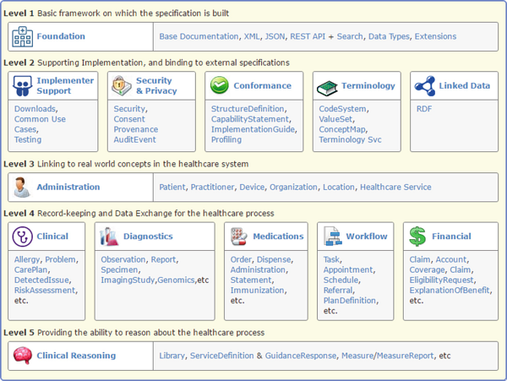
Fig. 9.1
FHIR resources are grouped into five levels (and within them by modules) that provide: (1) a basic framework; (2) support for implementation; (3) linkage to the healthcare system; (4) clinical documentation and data exchange; and (5) support for clinical reasoning. (Courtesy HL7)
This graphic is useful for understanding the scope of the standard and its most important resources, particularly for patient care. However, it is a simplified summary of the standard. In what follows we will be referring to the complete FHIR Resource Index page that lists virtually all of the currently defined resources.⁵
At the time of this writing the levels and their resource counts on that page were:
- Level 1: Foundation – The standard’s basic framework (30 resources)
- Level 2: Base – Support for implementation and binding to external specifications (26 resources)
- Level 3: Clinical – Structural and process elements of real world healthcare systems (37 resources)
- Level 4: Financial – Record-keeping and data exchange (43 resources)
- Level 5: Specialized – Providing the ability to reason about healthcare processes (11 resources)
The levels are also illustrated in Fig. 9.2 which more functionally subcategorizes each level and adds a sixth level that consists of Profiles and Graphs, two tools that are used to specify the application of FHIR to a particular use case. We will discuss these later on in this chapter.
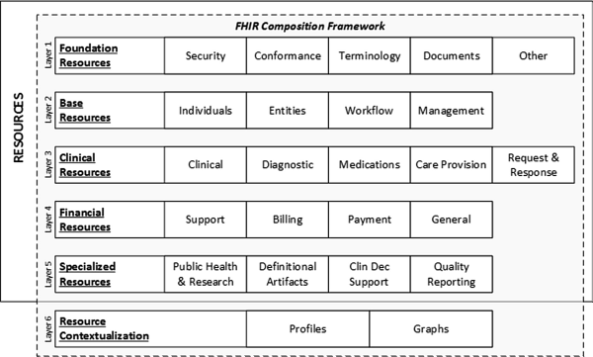
Fig. 9.2
The FHIR health information model sub-categories organized into layers based on how frequently that are anticipated to be used. The categories at the top layers are the most commonly used so they contain the FHIR resources that support the largest number of healthcare transactions and therefore need to be the most consistently defined and tightly governed. (Courtesy HL7)
At present, FHIR is in its third version of a standard for trial use (STU3) and there are 147 resources on the Resource Index page, around the estimated number for the initial normative version of FHIR that will likely be released in late 2018. You may see the term Draft Standard for Trial Use (DSTU), but STU is now HL7’s preferred term. An STU4 will precede the first normative version.
It is likely that the number of resources will increase over time and existing ones may change, so the HL7 FHIR Resource Index page will be the most up-to-date source of this information. It summarizes the resources and their sub-divisions in several useful ways. If you visit this page note that the number after each resource indicates its maturity on a scale of 0–5. Those numbers will increase over time as standards definition proceeds. At present, the resources in the lower numbered of the five levels listed earlier are generally more mature.
There are a few particularly interesting resources that support the FHIR framework or suggest interesting new directions for the standard:
- The definition of a resource is itself contained in the Resource resource that is not listed on the Resource Index page but can be found in the Foundation Module. This is only one of 17 resources used in this module but, unlike the others, it is strictly definitional so there would never be an actual Resource resource in a patient record.
- Earlier, we said that Value Sets can be represented in a resource. It is the ValueSet resource in the Terminology Module that “provides an overview and guide to the FHIR resources, operations, coded data types and externally-defined standard and FHIR-defined terminologies that are used for representing and communicating coded, structured data in the FHIR core specification and profiles”.
- Later, we will discuss FHIR profiles. These are represented in a computable StructureDefinition resource found in the Conformance division of the Foundation level on the Resource Index page.⁶
- The Group resource in the Individuals divisions of the Base level on the resource list page specifies a particular set of patients, providers, medications, etc. for purposes such as reporting or tracking.⁷ They are likely to be an important component of the newly proposed but not yet formally defined Bulk Data Protocol we will discuss later.
- The current FHIR information retrieval paradigm is ‘pull’. An app or other system or tool needing information sends a RESTful API query to obtain it. The Subscription resource in the ‘Other’ division at the Foundational level is used to create a ‘push’ of FHIR resources that match criteria specified in the resource. Updated information would be sent along without being further requested. This is a potentially important direction for the standard. Helping clinicians keep track of their patients could be facilitated if updated information automatically appears and is brought to their attention. One important example of this are critical laboratory results which can have an impact on timely and appropriate care or can help make timely decisions about discharging patients from the emergency department or hospital bed.⁸
- One of the major limitations of current clinical systems is their lack of knowledge of and inability to support optimal workflow and process. This not only leads to inefficiency but medical errors such as when a critical laboratory result doesn’t reach its intended recipient. The Workflow Module (not a module in the sense of the ones we just discussed) also suggests an important new direction for the standard that Grahame specifically mentioned in an interview I did with him in the fall of 2017. The primary aspects of this ‘informative’ group of resources are:
  - How do we ask for another person, device or system to do something?
  - How do we track the linkages and dependencies between activities – actions to their authorizations, complex activities to individual steps, protocols to plans to orders, etc.?
  - How do we define what activities are possible and the expected order and dependencies of the steps within those activities? i.e. process/orchestration definition
- Finally, Level 5 includes support for Clinical Reasoning. Earlier, we discussed clinical decision support and the benefit of tight EHR integration using FHIR as a key strategy to obtain provider adoption of these tools. The new CDS Hooks specification, developed by the same group that created SMART on FHIR, supports the integration of clinical logic into EHRs to, among other things, automatically indicate the availability of applicable FHIR apps when a patient’s clinical situation suggests they might be of value. A goal of FHIR STU 4 is to unify the CDS Hooks specification with the Clinical Reasoning module. This should be another important step toward broader use of CDS.

9.5 FHIR Resource Representations
There are examples on the HL7 FHIR site of most Resources in XML, JSON and Turtle formats. XML (eXtensible Markup Language) and JSON (Javascript object notation) are two text-based standards for open data sharing on the Internet. XML is older but JSON is being widely adopted because it is less verbose and, hence, easier to parse. You saw examples of both when we discussed HL7 V2 and V3 messages. The JSON representation of FHIR resources is by far the most commonly used at present.
The list of FHIR modules included “Linked Data” and its brief description referred to RDF . Turtle (Terse RDF Triple Language) is a format used by the World Wide Web Consortium (W3C) in its Resource Description Framework (RDF) data model for the proposed semantic web in which data in web pages is structured and tagged so that it can be read (some might say ‘understood’) directly by computers. To support this RDF extends the linking structure of the Web using Universal Resource Identifies (URIs) to describe relationships between things as well as the two ends of the link in a “triple” comprising a subject, predicate and object, each of which can be a URI. This should remind you of our earlier discussion of semantic interoperability.
Figure 9.3 suggests how this construct could power a semantic web that understands entities and their relationships.⁹ In it, as is often the case, the Mona Lisa is at the center of attention. Bob is a person who likes this painting created by Leonardo da Vinci. As in our earlier discussion of semantic interoperability, it is worth considering whether there is a need for a semantic formalism in an era when machines are increasingly figuring these things out. There is a discussion of representing FHIR Resources in RDF on the HL7 site.¹⁰ There is also a W3C Semantic Web Health Care and Life Sciences Interest Group.¹¹ The possible use of this representation would be of obvious interest to the semantic interoperability community and an HL7 group has been created to further define the use of RDF in FHIR.¹²
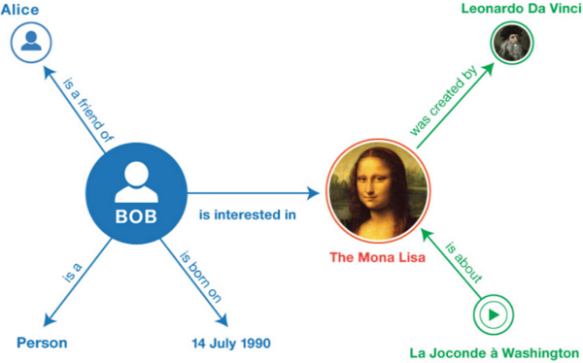
Fig. 9.3
A simple graph illustrates the kind of relationships the RDF seeks to codify. (Courtesy W3)

9.6 FHIR Resource Examples
Figure 9.4 illustrates some key parts of an XML-formatted FHIR patient resource:
- Local information, such as its last update and its local resource ID (the value that can be used to find this instance of the resource on this particular server)
- An HTML presentation of the key information for human consumption or for display by the receiving system if it is not able to interpret the structured information
- Any local extensions to the standard
- The standard defined data content.
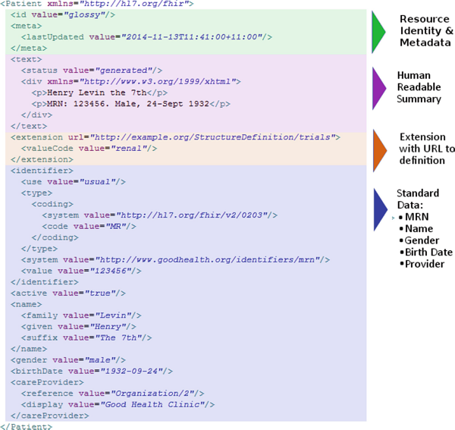
Fig. 9.4
The key components of a FHIR resource include local data, human readable data, any extensions used in this resource and its contents as defined by the FHIR specification. (Courtesy HL7)
Figure 9.5 is an example of the structured part of a JSON-formatted FHIR AllergyIntolerance Resource. It begins by showing that this allergy problem is clinically ‘active’ but is ‘unconfirmed’. Patients often report allergies, but that does not mean they experienced an actual allergy as opposed to a medication side effect. This allergy is for Penicillin G and, according to the Mayo Clinic, research has shown that penicillin allergies may be over diagnosed and that patients may report a penicillin allergy that has never been confirmed. A misdiagnosed penicillin allergy may result in the use of less appropriate or more expensive and possibly more dangerous antibiotics.
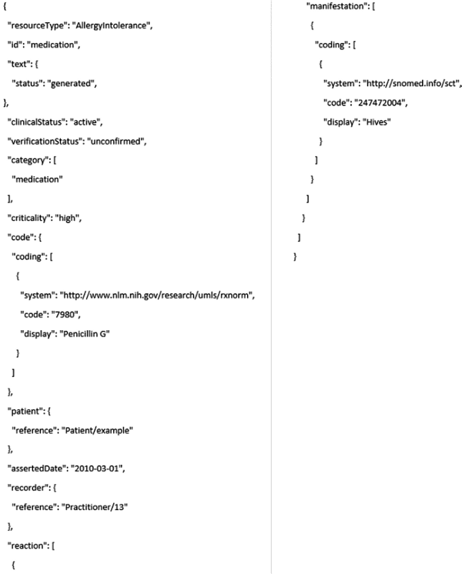
Fig. 9.5
The structured part of a JSON-formatted FHIR AllergyIntolerance Resource documents that it is active but unconfirmed, relates to a medication and is deemed critical. It goes on to specify that the medication is Penicillin G (coded in RxNorm); to indicate who the patient and provider are by providing their resource IDs on this server; and to document that the allergy is manifested by hives (coded in SNOMED-CT). (Courtesy HL7)
Next it documents that this allergy is in the Medication Category. ‘Medication’ is one of four allowed values for an allergy/intolerance category. Figure 9.6 shows this Value Set – the list of allowed values for this data element – taken from the relevant page on the HL7 FHIR site.¹³ Food, environmental and biologic allergies (such as to an X-ray contrast agent or a vaccination) can also be documented using this resource. Knowing that it is a medication allergy could be helpful to software so that it knows to check on it when prescribing new medications.
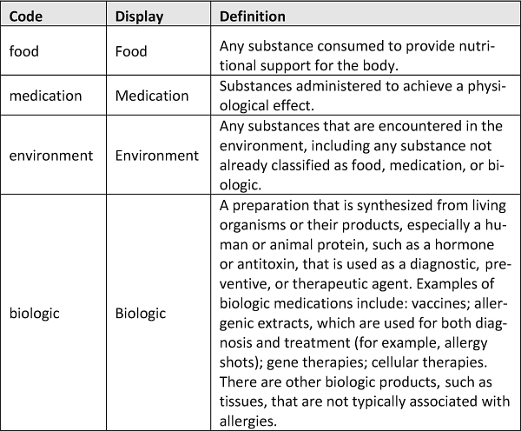
Fig. 9.6
The Value Set or list of allowed values for the allergy category. (Courtesy HL7)
Next is a reference to an RxNorm code or RXCUI – 7980 – for Penicillin G. Actually, penicillin is a group of antibiotics and this is only one part of that group. Patients allergic to one member of the group are presumed to be allergic to the entire group, so an RXCUI of 70618 might have been a better choice. You can verify that and find out what this RXCUI is for using the RxNorm tool suggested to you earlier.
Finally, the resource documents that the allergy manifests itself as hives, an outbreak of swollen, pale red bumps or plaques (or wheals) on the skin. The SNOMED-CT code provided should be for hives. You can verify that with the SNOMED browser you may have used earlier.
The references to RxNorm and SNOMED-CT illustrate an important characteristic of FHIR we mentioned earlier – it builds upon existing standards – via “Terminology Bindings” that specify these relationships. Figure 9.7 shows all the terminology bindings for this one resource. There is a page on the FHIR site listing all the terminology bindings referenced in the standard.¹⁴
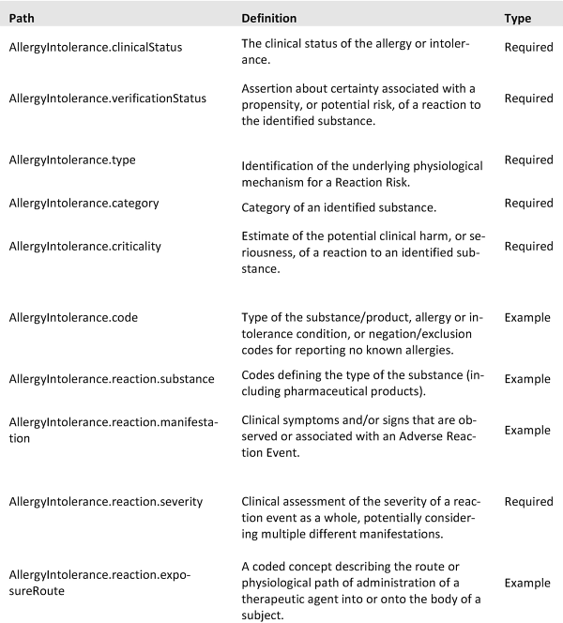
Fig. 9.7
The list of references to value sets and external codes (terminology bindings) used in the AllergyIntolerance Resource
Figure 9.8 illustrates how FHIR also rests on key elements from earlier HL7 standards. For example, the marital status value set comes from HL7 V3. If you go to the Detailed Description tab on the Patient Resource page on the FHIR site, you will find Patient.maritalStatus.¹⁵ Click on its Marital Status Codes link and you will get to this table.
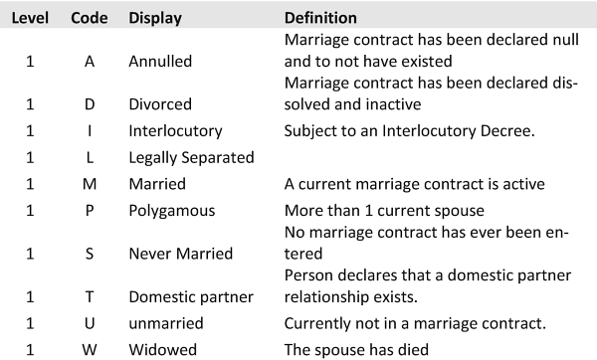
Fig. 9.8
The value set for marital status used in FHIR derives from HL7 RIM

9.7 FHIR Resource Activity
David Hay, a leader in the FHIR community and the developer of the excellent clinfhir web tool for exploring FHIR has posted a video that demonstrates the use of clinfhir to create FHIR Resources.¹⁶ This is something you may wish to try yourself using David’s wonderful tool.

9.8 FHIR Extensions
The 80% rule inevitably means that the FHIR standard does not cover all use cases. FHIR extensions serve the needs of a use case with specific requirements or a user community with specific interests or needs. HL7 maintains a registry of extensions so that implementers can take advantage of already defined extensions and avoid duplication.¹⁷
Figure 9.9 is a simple example of a FHIR extension to the AllergyIntolerance Resource we saw earlier. It provides a structured way of recording the age at which the allergy resolved. Childhood allergies to food do often resolve during later childhood or adolescence and would be a common use case for this extension. Note that to assure consistency, the status of a resource using this extension should be ‘resolved’.
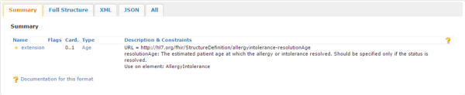
Fig. 9.9
An extension to the FHIR Allergy Intolerance resource documents the age at which it resolved and might be particularly useful in a pediatric environment. (Courtesy HL7)

9.9 FHIR Resource IDs
Earlier in Figs. 9.4 and 9.5 you saw examples of FHIR Resource IDs. FHIR Resources have a logical identity or ID that is unique among all resources of the same type on each FHIR server. Just to be clear, this ID will usually be different on each FHIR server so it cannot, for example, establish patient identity across servers. However, there is a discussion of the use of FHIR for a Master Patient Index on the Patient resource page¹⁸ and there is even the value set shown in Fig. 9.10 to indicate the quality of a patient query match. This illustrates how rich the FHIR standard is becoming. You should use the many public web resources and tools to explore it further.
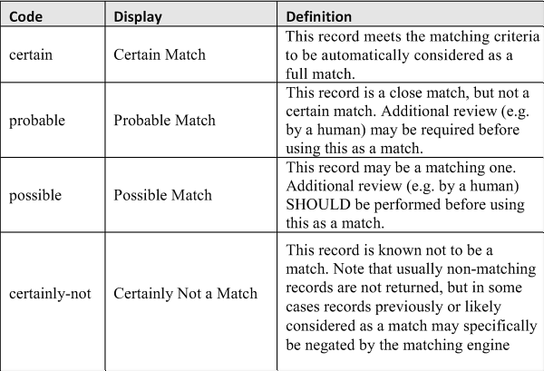
Fig. 9.10
The value set for use in indicating how precisely a patient has been matched to information presumably provided by an outside system. (Courtesy HL7)
The unique identifier of a resource instance is an absolute URI constructed from the server base address, the resource type and the logical ID. When the literal identity is an HTTP address, this address can generally retrieve or manipulate the resource as illustrated in Fig. 9.11 using a public instance of the HAPI FHIR server. In this example the URI is https://fhirtest.uhn.ca/baseDstu3/Patient?identifier=3535 . The three parts of the URL are: the server base address of fhirtest.uhn.ca/baseDstu2/; the resource type of patient; and the resource ID of 3535. In the body of the figure you see that, as it should, the internal reference to the Resource ID matches the one in the URL.
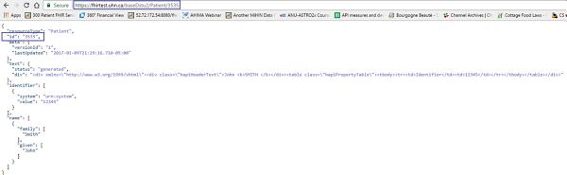
Fig. 9.11
The use of a unique identifier to create an absolute URI to retrieve that resource. In this case it is https://​fhirtest.​uhn.​ca/​baseDstu3/​Patient?​identifier=​3535. (Courtesy University Health Network)
You should easily be able to do something similar using any public FHIR server. We will discuss those later. Keep in mind that they are essentially ‘playgrounds’ and there is no assurance that data will persist so do not be surprised if the examples given in the book don’t work for you. Instead, simply search for a Resource giving no specifications to bring up all the instances of that resource. However, you should also definitely study the dropdown lists of search criteria available to you. Use one to search for something fairly likely to be present (e.g. patients with a Family Name of “Smith”). Pick one and then note its literal URL and the three parts that make it up. Before moving on note the use of “DSTU” in the URL. As mentioned earlier, you are likely to run into this even though the preferred term is now STU. They are equivalent.
Resource IDs can be up to 64 characters long and contain any combination of upper and lowercase ASCII letters, numerals, “-” and “.”. Note that the ID for the patient earlier was “example” and that could actually be an ID.
The AllergyIntolerance resource example (Fig. 9.5) we have been exploring has ID references for the patient (‘example’) who has this allergy as well as to the practitioner (‘13’) who recorded it. As shown in Fig. 9.12, using these references FHIR Resources create a network of information that is somewhat like the hierarchy of relationships coded into SNOMED-CT.
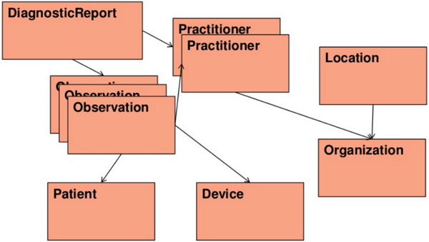
Fig. 9.12
FHIR can be thought of as creating a network of information via the references within many FHIR resources to other related resource. These references are of obvious value to app developers. (Courtesy HL7)

9.10 FHIR Enabling Existing Systems
In real-world scenarios health system vendors usually create FHIR Resources from data stored in a proprietary clinical database designed and built before FHIR existed. When a FHIR app or REST API asks for a resource special software, often called a FHIR adapter or server, must know how to get the needed data elements from the system’s database and package them into the FHIR Resource format.
The data that populates that FIHR resource will therefore depend on the underlying system. If that system stores clinical observations only as text then, even though FHIR includes them, LOINC codes will not be available in the FHIR resources that system creates. Of course, the designers of the FHIR adapter might make the effort to add any missing codes but, at present, that is not typical.
Moreover, there are often many LOINC codes for similar lab tests or clinical observations so different systems may provide different codes. Commercial products are starting to appear that seek to aggregate and even normalize data from different sources to create a more consistent set of FHIR resources. Earlier we saw that Human API and the Google Health Cloud have developed a middleware layer to add missing codes and potentially validate codes that are present. These functions have long been a part of software designed for health information exchanges so it is not surprising that these are being extended to FHIR by HIEs. One early example is InterSystems’ HealthShare HIE software that typically aggregates data from multiple electronic health records and other systems using whatever interfaces are available from the vendors of those systems. The company says that “now all the data for an individual or a population can be transformed and aggregated as a FHIR representation, and applications developed with FHIR can access it.”¹⁹
Many major healthcare enterprise software vendors, including Epic, Cerner and MEDITECH (the three most widely installed) have released at least preliminary versions of a FHIR server. As of this writing Epic and Cerner and some other EHR vendors have released integrated support for the SMART on FHIR app platform and MEDITECH indicates that it plans to release support (but, at present, this may be limited by some vendors to patient facing apps because that’s a requirement for Meaningful Use Stage 3). We will look at examples of this later on. Finally, again at present, most vendor support is only for reading resources. Support for the rest of CRUD is more difficult for vendors to implement because of the need to implement various checks and edits and other safeguards necessary to maintain the integrity and consistency of their databases so support beyond read only will appear more slowly.
HL7 maintains a web page that summarizes the ever-growing list of health IT system vendors and other organizations interested in FHIR along with a link to their sites, contact information and a brief description of their intended use of the standard.²⁰

9.11 FHIR API
This discussion is a bit more technical but it should be possible for all readers to get the general concepts.
Client-server is an architecture in which data is stored on a central system (server) and is made accessible to remote (client) computers or other devices via some network. The Internet is, of course, a dramatic global extension of this architecture. Some protocol or standard is required so that the clients and servers understand each other. Representational State Transfer (REST) is by far the most common protocol on the Internet and it relies on a stateless, client-server, cacheable communications protocol that is usually HTTP. You use this protocol on a daily basis when you access public and even private web sites.
Statelessness essentially means that all of the necessary information to handle the request is contained within the request itself, whether as part of the URI, query-string parameters, body, or headers. You saw an example of that earlier when we retrieved patient 3535. The FHIR server only needed the information in the URL to do that. Thus, any machine in a vast server farm (such as those managed by Amazon, Google and others) can handle the request, return the appropriate response and immediately be available for the next request. A moment’s reflection should reveal to you why this is an attractive characteristic for anyone managing a large public site. The response from the server to the client is similarly self-contained.
In FHIR, the four HTTP verbs POST, GET, PUT, and DELETE implement CRUD. POST creates new resources. GET reads existing resources. PUT and DELETE update or remove existing resources. I mention these because you may well see them if you further explore FHIR.
Figure 9.13 is a complete list of the currently defined logical FHIR interactions . This part of the standard is at Maturity level 5 so it is essentially in final form. Note its three sections: Instance, Type and Whole System interactions.
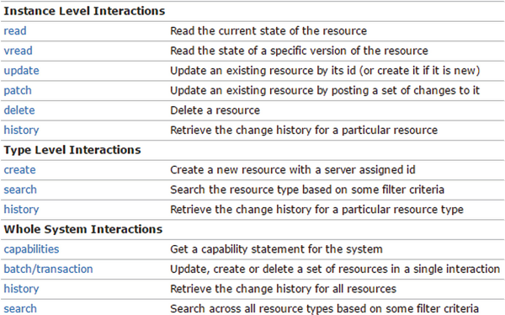
Fig. 9.13
A complete list of the defined FHIR API interactions between a FHIR client/app and a FHIR server. They are divided into Instance, Type and Whole System interactions. (Courtesy HL7)
The Instance section deals with individual resources. Note that PATCH , a fifth HTTP verb, can also be used when a client is seeking to minimize its bandwidth utilization or, in the more likely scenario, when a client has only partial access or support for a resource, a fairly likely situation in healthcare given the emphasis on privacy and security.
The Type section deals with a group of related resources. Note that here FHIR defines HISTORY and SEARCH , two interactions of particular interest in healthcare.
HISTORY retrieves a set (called a “bundle”) of either a particular resource, all resources of a given type, or all resources supported by the system. It can be quite useful given the clinical importance of trends and changes in patient status.
Earlier you should have inspected the variety of search criteria available in FHIR. This should have convinced you that SEARCH is a particularly rich and important part of the FHIR standard. In the simplest case, a search is executed using a GET operation where a series of name=[value] pairs encoded in the URL specify the parameters.
Searches are constrained to one of three contexts in order to control what resources are considered:
- A specified resource type: GET [base]/[type]?parameter(s)
- A specified compartment that might be a specific patient, as illustrated in Fig. 9.14, perhaps with a specified resource type in that compartment: GET [base]/Patient/[id]/[type]?parameter(s)
- All resource types: GET [base]?parameter(s) where the parameters must be common to all resource types
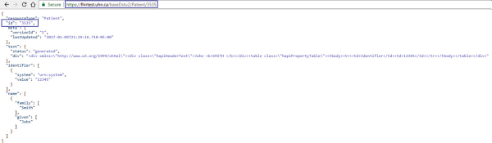
Fig. 9.14
An example of a FHIR API to retrieve a specific patient using their ID on the server where the query is performed. (Courtesy University Health Network)
Finally, in the Whole System section, the Capabilities operation retrieves the server’s Capability Statement describing the server’s current operational functionality. Clients connecting to a FHIR server can use the capabilities interaction to check whether they are version and/or feature compatible with the server or whether it can support a specific use case of interest. Along with the StructureDefinition resource we discussed earlier as the computable representation of a FHIR Profile, this is a key part of the FHIR conformance layer that consists of the StructureDefinition and Conformance resources as well as an Implementation Guide.
If the reasons for this are not clear to you, keep in mind that the FHIR specification describes a set of resources and, at present, three frameworks for exchanging resources between different systems. Because of its general nature and wide applicability, the rules made in this specification are generally fairly loose so different applications may not be able to interoperate because of how they use optional features.
Applications claim conformance to one (or more) of these three FHIR exchange frameworks (or paradigms in which FHIR may be used):
- RESTful FHIR: The RESTful API for resource-by-resource interaction between a FHIR app or client and a FHIR server.
- FHIR messaging : Message based exchange that involves a group (bundle) of FHIR resources that together could represent something like an HL7 message.
- FHIR documents : Document based exchange involves a typically larger bundle of FHIR resources that together could represent something like an HL7 C-CDA document.
Importantly to developers the FHIR resources are consistent across these three paradigms further simplifying app development.
An important future direction for the FHIR API is signaled by the following statement in ONC’s Draft Trusted Exchange Framework released in January 2018: “Within twelve (12) months after the FHIR standard with respect to Population Level Query/Pulls has been formally approved by HL7, each Qualified HIN [HIE] shall cause its Broker to be able to initiate and respond to all Query/Pulls for as many individuals as may be requested by another Qualified HIN in a single Query/Pull.”²¹ Later we will discuss the proposed FHIR Bulk Data Protocol to respond to this requirement.

9.12 FHIR Profiles and Graphs
The FHIR specification provides a “platform” that creates a common foundation on which a variety of different solutions can be implemented. Often this general specification requires adaptation to particular use cases. FHIR Profiles provide a means of constraining the standard for a specific use case. FHIR Profiles can specify a variety of restrictions such as which of the values specified in the standard are allowed within a value set for the use case(s) implemented using the profile. Alternatively, they might specify another value set that is more extensive or used in a special context. They can require that a data element be present. They can also add extensions to FHIR.
According to the FHIR site “Profiles are used to extend, constrain, or otherwise contextualize resources for a given purpose. Graphs are compositions of resources, or webs of resource[s], that contain attributes of their own.”²² Importantly Resources, Profiles and Graphs are all represented in their own resources making the specification of FHIR for a use case itself computable. This greatly facilitates the development of FHIR apps and tools that are correctly using the standard as intended for their particular use case(s).
Implementation Guides specify Profiles and contain the Conformance Resource specification for that use case. Argonaut is the best-known example of an Implementation Guide. The Argonaut Project is a collaboration of many private, major EHR vendors and other organizations to promote industry adoption of modern, open interoperability standards to meet the requirements of Meaningful Use and related regulations. This is a complex topic best explored using the information posted on the HL7 FHIR site.²³
The FHIR site also provides a more comprehensive discussion of the FHIR architectural framework and how it aligns with some widely used standard frameworks (such as the TOGAF Architecture Development Method, the Zachman Framework and HL7’s Services Aware Interoperability Framework (SAIF)) .²⁴

9.13 FHIRPath
Arguably one of the most attractive features of FHIR for developers is its composability. Each FHIR resource is an independent object and can be retrieved using an appropriate API query. This is distinctly unlike earlier standards such as C-CDA where an entire clinical document must be retrieved even if only one specific part of that document (such as a patient’s problem list) is of interest. To explore this in some detail we will use a new tool called FHIRPath that is implemented on David Hay’s wonderful clinfhir web tool.²⁵
Among other things, FHIRPath further extends composability to individual data types or even their values. FHIRPath is a path-based navigation and extraction language, somewhat like the XPath language defined by W3 and which can be used to navigate through elements and attributes in an XML document. FHIRPath does the same for FHIR and can navigate through and retrieve specific sub-elements of a large FHIR Bundle which might, for example, be an entire patient record. When the FHIR Bulk Data Protocol is implemented this bundle could even be all the records of patients in a “group” that could, for example, specify only patients with a particular insurance plan.
The technical details of FHIRPath are beyond the scope of this book but we can easily see how useful it could be using some examples. One of clinfhir’s many attractive features is the generation of some sample data so that a new patient begins with a reasonable facsimile of a medical record. This is illustrated in Fig. 9.15 where we have checked the ‘Generate samples’ box.
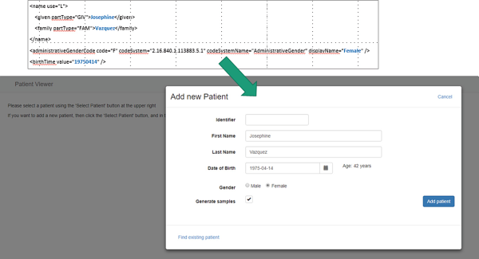
Fig. 9.15
An example of using clinfhir to generate a new patient with a variety of FHIR resources containing make believe data (by checking the ‘Generate Samples’ box). (Courtesy David Hay)
The resulting 72 FHIR Resources are indexed of the left in Fig. 9.16. The single Patient resource is selected and its contents are displayed on the right in a human friendly ‘tree view’. Note that this patient’s Patient Resource has been assigned the ID 299014, a number that can be used to easily retrieve it or, depending on the capabilities of an individual FHIR server, to specify that other resources, such as medications or clinical observations, are to be retrieved, but only for this patient.
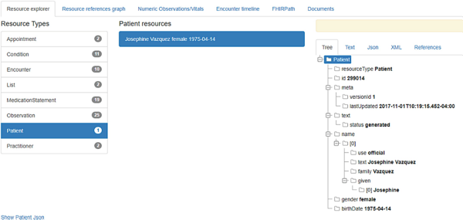
Fig. 9.16
On the left clinfhir indexes the FHIR resources generated for the make believe patient requested previously. The single Patient resource is selected and is displayed on the right in a human friendly tree view. (Courtesy David Hay)
The Patient Resource can be represented in XML or in JSON, as shown in Fig. 9.17. It should be easy to see that the data that is shown in the tree view is the same as in this JSON representation.
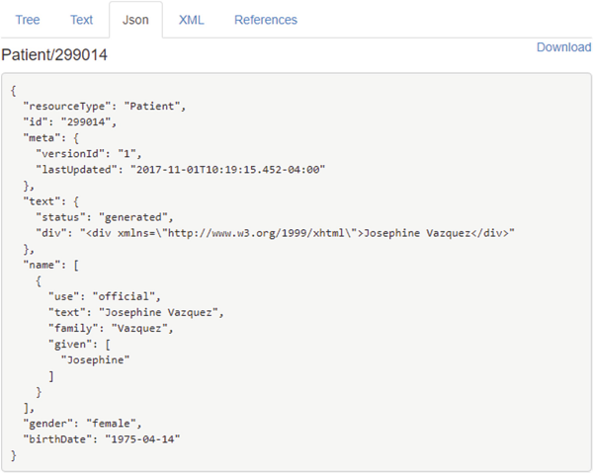
Fig. 9.17
The JSON representation of the patient confirms the source of the data shown in the tree view. (Courtesy David Hay)
clinfhir’s FHIRPath exploration arm makes it easy to create a bundle containing our patient’s entire record, as shown in the middle part of Fig. 9.18.
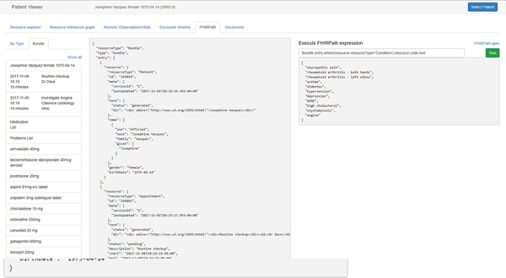
Fig. 9.18
clinfhir’s FHIRPath tool creates a bundle containing our patient’s entire record. This is ideal for further exploration using the FHIRPath language. (Courtesy David Hay)
It may be a simplistic representation of a patient record but, displayed in Microsoft Word, this bundle occupies 96 pages and is 5401 words long. We already know that we can use the FHIR API to retrieve a part of this bundle such as only the Condition resources. Suppose that we aren’t interested in the entire contents of the Condition resources because we only want to display the patient’s medical problems as text in a hypothetical FHIR app. That information is contained in those Condition resources and it would certainly be possible to parse it from them. FHIRPath makes that simple to do, as shown in the right pane of Fig. 9.17. There, the FHIRPath expression
Bundle.entry.where(resource.resourceType='Condition').resource.code.text
produces exactly the text needed to display the patient’s medical problems as you can see on the right below this expression.
To give another example, the following FHIRPath expression uses the appropriate LOINC code to produce a list of measurements for a particular clinical observation, as shown in Fig. 9.19. I leave it to you to use the LOINC code to figure out what specific clinical measurement this is.
Bundle.entry.where(resource.resourceType='Observation').where(resource.code.coding.code='8867-4').resource.valueQuantity.value
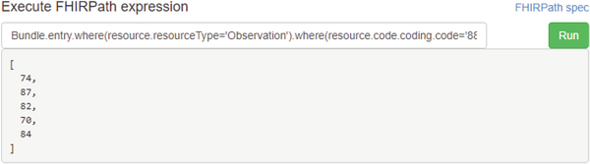
Fig. 9.19
This FHIRPath expression retrieves only the numeric values of the clinical observations with a LOINC code of 8867-4. (Courtesy David Hay)
Capabilities such as FHIRPath make app creation far easier and faster leading to more rapid innovation and more usable software tools.
For example, from this list it should be easy to create a graph over time, as shown in Fig. 9.20. While this may seem to be a simplistic example many commercially available EHRs cannot yet graph results like this and a FHIR app using FHIRPath would both be quite simple to implement and could be a useful tool for providers using one of those EHRs.
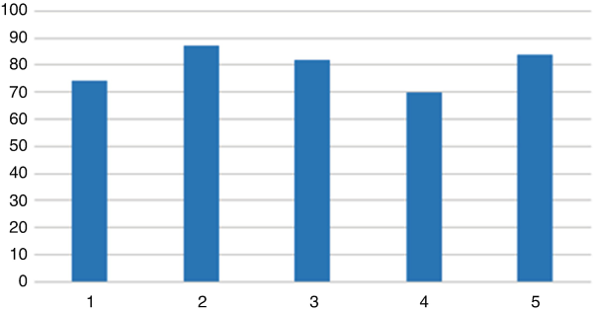
Fig. 9.20
The results of the FHIRPath expression shown in Fig. 9.18 are graphed to illustrate how approachable working with clinical data becomes if it is FHIR accessible
Later we will discuss the role that FHIRPath will play in the FHIR specifications for quality measurement and clinical decision support.

9.14 Public FHIR Servers
Non-technical readers wishing to explore FHIR on their own would do well to use clinfhir. For those readers with at least some coding skills there is an increasing number of public FHIR servers and HL7 maintains a directory of these. It is well worth reviewing the descriptive information posted in the directory to get a sense of the variety of services available.²⁶
Many of these public servers will share a user interface because they are based on the open source HAPI implementation of the FHIR specification done in Java by James Agnew , a co-chair of HL7 and an editor of the FHIR standard.²⁷ He is also technical lead for SMILE CDR which provides commercial products based on the code. Among other things SMILE CDR provides a FHIR enabled HIE solution²⁸ Readers with an interest can download the HAPI code from GitHub and create their own FHIR server.²⁹ The most widely known public test server based on HAPI is provided by the University Health Network in Toronto.³⁰
Commercial EHR vendors are creating ‘sandboxes’ to facilitate development of FHIR apps for their platform. Among the first of these are the major EHR vendors Cerner,³¹ Epic³² and Allscripts®.³³
The data available on most publicly accessible FHIR servers can be of highly variable quality, utility and persistence. One interesting exception is SyntheticMass developed by the MITRE Corporation , a not-for-profit company that operates multiple federally funded research and development centers and has had a long-standing involvement in health informatics. The data stored on this server consists of what MITRE calls “realistic but fictional residents of the state of Massachusetts” that “statistically mirror the real population in terms of demographics, disease burden, vaccinations, medical visits, and social determinants.” The data was produced by MITRE’s open source Synthea tool.³⁴ The entire dataset can be graphically explored on the site and it can also be accessed via FHIR queries.³⁵ A number of example queries are provided on the site.³⁶

9.15 FHIR Recap
As time passes the momentum toward FHIR seems to be growing at an increasing rate. To get a sense of this it is well worth attending one of HL7’s FHIR Application Roundtable meetings that provide a large number of short presentations/demos from a wide variety of sources including providers, vendors (including increasingly large companies), academic institutions, start-ups and even individuals. HL7 members can view prior presentations on the organization’s site.³⁷ Anyone attending this series of meetings would likely note the increasing size of the commercial companies presenting and the increasing scope and apparent maturity of the products, systems and platforms they are offering.
It now seems clear that HL7’s fresh look may indeed have led us to the long-sought solution to interoperability, or at least its first two layers – transport and structure. In what follows we will explore what can be done using FHIR to help solve the many problems of healthcare delivery with which we began this book. First, we will explore SMART on FHIR, the increasingly ubiquitous and also long sought universal health app platform.
Footnotes
1
http://​www.​healthintersecti​ons.​com.​au/​?​p=​502

2
http://​www.​healthintersecti​ons.​com.​au/​?​p=​137

3
http://​www.​healthintersecti​ons.​com.​au/​?​p=​1924

4
https://​www.​hl7.​org/​fhir/​overview.​html

5
https://​www.​hl7.​org/​fhir/​resourcelist.​html

6
https://​www.​hl7.​org/​fhir/​structuredefinit​ion.​html

7
https://​www.​hl7.​org/​fhir/​group.​html

8
https://​www.​hl7.​org/​fhir/​subscription.​html

9
https://​www.​w3.​org/​TR/​rdf11-primer/​

10
https://​www.​hl7.​org/​fhir/​rdf.​html

11
https://​www.​w3.​org/​2011/​09/​HCLSIGCharter

12
http://​wiki.​hl7.​org/​index.​php?​title=​RDF_​for_​Semantic_​Interoperability​

13
http://​hl7.​org/​fhir/​ValueSet/​allergy-intolerance-category

14
http://​hl7.​org/​fhir/​terminologies-valuesets.​html

15
https://​www.​hl7.​org/​fhir/​patient.​html

16
https://​videos.​files.​wordpress.​com/​qIAx7Xbo/​clinfhir_​demo_​dvd.​mp4

17
https://​www.​hl7.​org/​fhir/​extensibility-registry.​html

18
https://​www.​hl7.​org/​fhir/​patient.​html

19
https://​www.​intersystems.​com/​fhir/​

20
http://​wiki.​hl7.​org/​index.​php?​title=​Organizations_​interested_​in_​FHIR

21
https://​www.​healthit.​gov/​sites/​default/​files/​draft-trusted-exchange-framework.​pdf

22
https://​www.​hl7.​org/​fhir/​overview-arch.​html

23
http://​www.​fhir.​org/​guides/​argonaut/​r2/​

24
https://​www.​hl7.​org/​fhir/​overview-arch.​html#framework

25
http://​clinfhir.​com/​

26
http://​wiki.​hl7.​org/​index.​php?​title=​Publicly_​Available_​FHIR_​Servers_​for_​testing

27
http://​hapifhir.​io/​

28
https://​smilecdr.​com/​

29
https://​github.​com/​jamesagnew/​hapi-fhir

30
http://​fhirtest.​uhn.​ca/​

31
http://​fhir.​cerner.​com/​

32
https://​open.​epic.​com/​AppExchange/​Sandbox

33
https://​tw171.​open.​allscripts.​com/​FHIR/​

34
https://​synthetichealth.​github.​io/​synthea/​

35
https://​syntheticmass.​mitre.​org/​fhir/​

36
https://​syntheticmass.​mitre.​org/​api.​html

37
https://​www.​hl7.​org/​events/​fhirapps.​cfm

