© Springer International Publishing AG, part of Springer Nature 2018
Mark L. BraunsteinHealth Informatics on FHIR: How HL7's New API is Transforming Healthcare https://doi.org/10.1007/978-3-319-93414-3_8

8. Pre-FHIR Interoperability and Clinical Decision Support Standards
Mark L. Braunstein¹
(1)
School of Interactive Computing, Georgia Institute of Technology, Atlanta, GA, USA

8.1 Introduction
In the last chapter, we looked at the evolution of standards and examined the key health data standards. For use in actual patient care, standardized clinical data, typically along with other non-standardized data such as free text notes, must be packaged into a useful and usable form and sent using widely accepted data sharing standards and approaches. Many people feel that these standards and approaches will increasingly be FHIR APIs but FHIR is still being developed and the first ‘normative’ version isn’t expected until late 2018 so for some time into the future earlier standards will continue to be used. We will look at FHIR in the next chapter, while in this one we will look at the standards for packaging and sharing data that predate it.
We will also look at Arden, a standard for the representation of clinical logic for decision support that was arguably ahead of its time. Arden is interesting and discussing it in some detail should serve to set the stage for later discussions of the key role that FHIR can play in making decision support tools for improved patient care easier to implement and use.

8.2 HL7 Evolution
What follows is an overview of many of the key components of HL7 with a particular emphasis on those that support data sharing for care coordination and patient engagement. It is important to keep in mind that, over the years, HL7 has expanded greatly from its original messaging mission and from the basic, but pragmatic, approach taken in V2 message standards development. The results of these newer efforts have not been widely adopted and some would now argue that this is because HL7’s later standards were overly complex and too difficult and expensive to implement in practice.

8.3 HL7 V2 Versus V3
The last chapter provided a simple comparison of HL7 V2 and V3 messages. We will now look at that in more detail to help us understand the evolution of HL7 standards development.
HL7 V2 is not “Plug and Play”. The concept was just getting started back then in the hardware world and certainly was not very common. V2 provides 80% of the interface and a framework to negotiate the remaining 20% on a case-by-case basis. Thus, developing an HL7 interface between any two systems requires coding and has a certain degree of customization. Part of the reason why, is that V2 was not based on a standard model.
A key goal of HL7 V3 development was to get as close to “Plug and Play” as possible. As we have discussed, it uses the Reference Information Model (RIM) in an effort to provide consistency across the standard.

8.4 Reference Information Model (RIM)
The goal of the HL7 Reference Information Model or RIM is to document the actions taken to treat a patient. A request or order for a test is an action. The reporting of the test result is an action. Creating a diagnosis based on test results is an action. Prescribing treatments based on that diagnosis is an action. RIM defines the semantics of a common set of administrative, financial and clinical concepts in order to describe these actions and foster interoperability.
Figure 8.1 is a simple diagrammatic representation of the four core RIM concepts or backbone classes (entity, role, participation and act) and their relationships. Every happening is an Act that is either being done, has been done, can be done or has been requested or ordered. Examples include clinical observations, medication administration, medical procedures, or patient encounters.
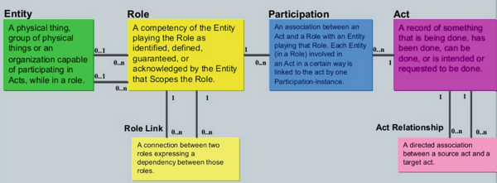
Fig. 8.1
Health Level Seven (HL7) RIM uses an object-oriented modeling approach derived from four main classes: Entity, Role, Participation and Act. (Courtesy HL7)
Act relationships represent connections between acts such as composition, preconditions, revisions and support. Participation defines the context for an Act such as author, performer, subject, or location. The participants have Roles such as patient, provider, practitioner, specimen or healthcare facility. Entities such as persons, organizations, material, places or devices play these roles.
How can a single act class represent all of the elements of a clinical action – their definition, requesting or ordering them or reporting the result? This is the role of the Act “mood” code that specifies whether the Act is an activity that is defined, is an event, has been requested or ordered, or is promised or is the subject of a future appointment.
Figure 8.2 is an example of a patient registration message in both the V2 and V3 formats. You will not find anything related to RIM in the V2 message at the top. Lower down, in the V3 version <processingModeCode” code = “T”/> is highlighted. We have said that FHIR borrows value sets from RIM and to illustrate that on both the HL7 RIM and FHIR web sites you can find the table shown in Fig. 8.3 that explains the possible values of this code – its value set. ‘T’ indicates ‘Current Processing’ so that is the status of this patient’s registration.¹ , ²
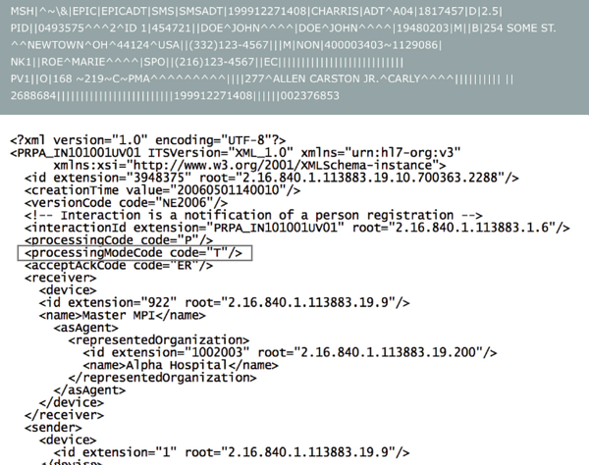
Fig. 8.2
A message of patient registration in both HL7 V2 messaging format (top) and V3 format (bottom) clearly illustrates the use of the RIM in V3. (Courtesy HL7)
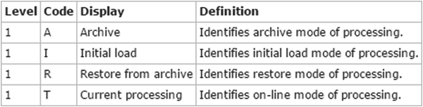
Fig. 8.3
This value set for the HL7 RIM processingMood is also used in FHIR. (Courtesy HL7)
The state of processing of an administrative task is but one example of the great level of detail encompassed by RIM. To get a further feel for this Fig. 8.4 highlights the specialArrangementCode for a Patient Encounter. Note that PatientEncounter is a leaf of the Act box meaning it is a particular example or instance.
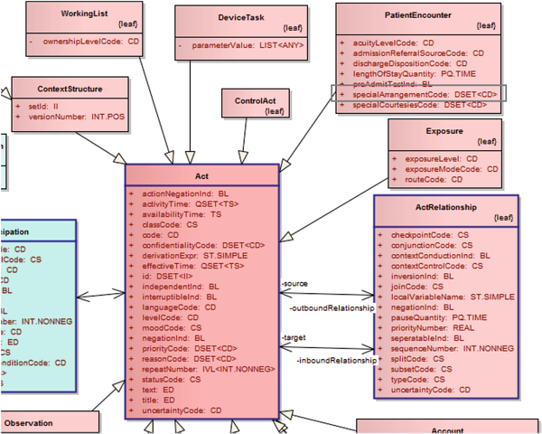
Fig. 8.4
The specialArrangementCode leaf of the PatientEcounter provides for special things a patient might need on arrival for that encounter illustrating the enormous level of detail encompassed by RIM. (Courtesy HL7)
The value of the specialArrangementCode is DSET indicating there is a discrete set of possible values (a value set) for this field. Once again, as you see in Fig. 8.5, the FHIR site lists this value set that codes for special things a patient might need at arrival for an encounter. The possible values are “wheel” for wheelchair, “add-bed” for additional bedding, “int” for interpreter, “att” for attendant and “dog” for guide dog.
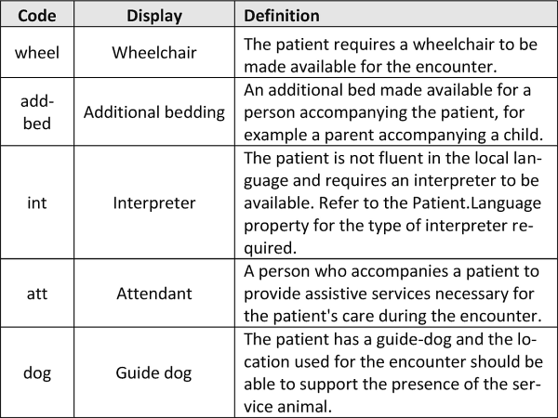
Fig. 8.5
The RIM value set for the specialArrangementCode of an encounter. (Courtesy HL7)

8.5 RIM and FHIR
You can find the ValueSets for many RIM codes on the FHIR site because FHIR builds on existing standards including the RIM. However, there are exceptions.
- Scope: It should be clear by now that the goal of RIM is comprehensive representation of the health care domain. FHIR resources represent only those data elements that are expected to be used by “most” implementations. FHIR uses an 80% rule – if at least 80% of standards contributors say they will need it, a resource will support a particular data element, as part of the core FHIR specification. You should read the post by Grahame Grieve on this often misunderstood FHIR design principle.³
- A specific sub-domain can add other elements, as needed, using FHIR extensions. FHIR Profiles both constrain resources (e.g. such as by specifying what values from a value set are allowed) for a particular use case and define extensions appropriate to special subdomains.
- Source of Data Elements: All data elements in HL7 V3 instances come from either the RIM or data types developed by the International Organization for Standardization (ISO). In FHIR, this is true of most, but not all, resources and data type elements. Some FHIR resources deal with content that is outside the RIM’s scope and, in a few instances, FHIR adjusts data types to accommodate issues not yet supported in RIM.
- Nuance: As you have seen, RIM attempts to convey the meaning of instances through attributes like the Mood Code. FHIR codes are generally limited to attributes with a rather concrete business meaning.
Finally, in FHIR a ValueSet is a resource that can be sent as part of an instance just like any other piece of data. As a result, although FHIR uses RIM data elements, it is possible to implement FHIR with absolutely no knowledge of the HL7 RIM. This greatly facilitates rapid development.
Before moving on to some of the things RIM is used for, it is important to emphasize again that the goal is interoperability and, in support of that, RIM can be used both for HL7 V3 messages and for clinical documents constructed, at least in part, from the data in them.

8.6 Clinical Document Architecture Uses RIM
The Clinical Document Architecture or CDA defines HL7 V3 RIM-based documents assembled from administrative and clinical data for particular purposes. You saw one of these if you did the HealthVault CCD activity. You should also recall that a consolidation effort produced the newer C-CDA standard. Figure 8.6 is the first part of the CCD you used in the HealthVault activity. The instances where it refers to the RIM are highlighted.
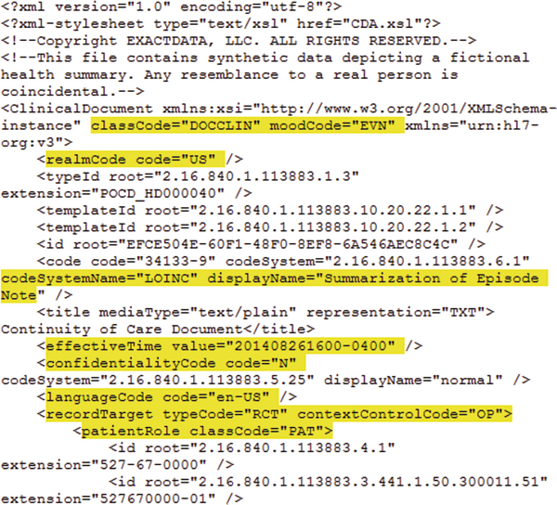
Fig. 8.6
A CDA document contains many references to the RIM. (Courtesy HL7)
I leave it to you to consider the balance between value, complexity and ease of implementation that this reliance on RIM entails.

8.7 C-CDA Templates
C-CDA documents are assembled from templates, essentially reusable XML components. Templates are defined at the document, section or data entry level. These correspond conceptually to the parts of a paper form where the document as a whole consists of sections, each of which consists of fields into which data is recorded.
Figure 8.7 is the same CCD we just looked at in Fig. 8.6 but the two references to templates are also highlighted but in a darker color.
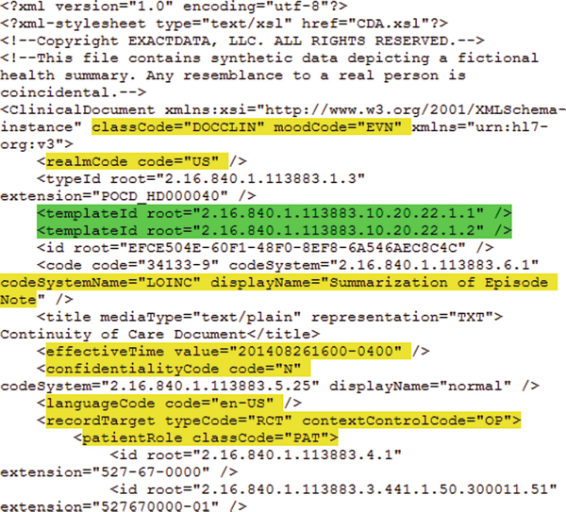
Fig. 8.7
To assure consistency to the standard C-CDA documents are built from reusable templates. These can be at the document level, section level or date entry level. Each has a unique OID (beginning with 2.16…). (Courtesy HL7)
There are C-CDA template guides posted including a graphically well-designed example from HL7.⁴ Templates have an OID, a globally unique ISO identifier. In Figs. 8.6 and 8.7, the first one has an OID of 2.16.840.1.113883.10.20.22.1.1. The second differs from the first only in the last digit. Both of these are document level templates. The first defines a document header for use in the US domain. This serves a purpose quite similar to the FHIR Profiles in that it constrains the document to US specifications. In Fig. 8.8 (from the template guide referenced earlier) you see that it specifies that there must be exactly one realm code and its value must be “US”.
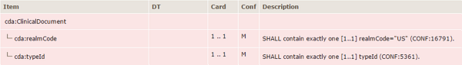
Fig. 8.8
This simple document level template simply specifies that it is for use only in the US realm using the CDA realmCode “<realmCode code=“US”/>”. (Courtesy HL7)
It is more interesting to look at the second template (Fig. 8.9) that specifies constraints for a Continuity of Care Document (CCD) in conformance with Stage 1 Meaningful Use. Here, you see that it specifies the sections that must be contained in the CCD so that it adequately supports use cases such as Transitions of Care. Each of these refers to a Section template and the HL7 site referenced earlier provides links to these more granular templates.
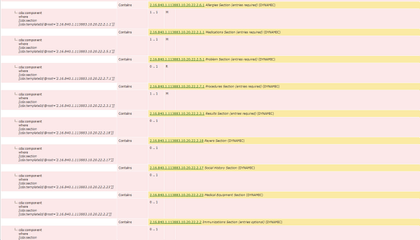
Fig. 8.9
The second document level template specifies the sections that must be contained in a US Continuity of Care Document (CCD) if it is to meet the requirements of Meaningful Use. Each link is to the corresponding section level template. (Courtesy HL7)
If you first click on the line to the Medications Section template and, from it, click on the MedicationActivity link you get to the Data Entry level template shown in part in Fig. 8.10. Note that it, in turn, links to specific ValueSets such as the Medication Route, Body Site, Units of Measure or Rate Quantity. Clicking on any of these links brings up a page listing the available values which, in the case of Route, came from an external source, the US Food and Drug Administration (FDA). It also links to specialized Data Entry templates. Not shown here is the Medication Information Entry Level template that could even contain a pre-specified product strength, product form, or product concentration (“amoxicillin 400 mg/5 mL suspension”). Clicking on its Medication Clinical Generic Drug link shows that the specification must be made using RxNorm.
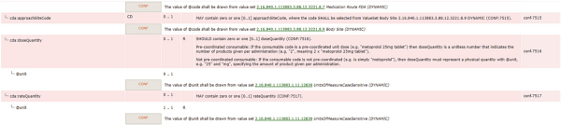
Fig. 8.10
Many data fields are limited to defined value sets that might come from external sources such as the FDA or RxNorm. (Courtesy HL7)

8.8 Clinical Decision Support
Clinical decision support (CDS) is an early, important and particularly interesting, domain within health informatics. Its purpose is to provide clinicians, patients and others with knowledge and personalized information, intelligently filtered or presented at appropriate times, to enhance health and health care. It is a critical component of the IOM’s vision of a Learning Health System since it is the vehicle for feeding knowledge obtained from the care of prior patients back to providers caring for current patients.
According to ONC, “CDS tools include computerized alerts and reminders to care providers and patients; clinical guidelines; condition-specific order sets; focused patient data reports and summaries; documentation templates; diagnostic support, and contextually relevant reference information, among other tools.”
We will discuss three key CDS projects to illustrate how early researchers recognized CDS as an opportunity and the challenges to successfully implementing it in practice. This discussion will set the stage for appreciating how two key capabilities of FHIR and SMART on FHIR are making CDS a far more approachable and clinically useful tool.
The first key capability is facile retrieval of EHR data in a standard format facilitating the integration of FHIR apps into any EHR. This also obviates the need for any redundant data entry by the provider. The second is seamless integration into the providers’ workflow making the use of CDS far more efficient and, therefore, more likely.
This discussion will begin with some of the most fascinating stories in the history of health informatics and the vision of some of its pioneers. Space does not allow for a full treatment of this particularly rich domain within the field and this discussion should not be construed as comprehensive since it does not describe all the projects worthy of inclusion.

8.9 Dr. Homer Warner’s HELP System
Beginning in the mid-1950s, Dr. Homer Warner, one of the founders of health informatics, began using computers for decision support in cardiology at LDS Hospital (now Intermountain Healthcare) in Salt Lake City. In the 1970s, Dr. Warner and his colleagues created the Health Evolution through Logic Processing or HELP system, one of the first electronic medical record systems, and perhaps the first designed to assist clinicians in decision-making. Intermountain replaced HELP2, the successor to HELP, with the Cerner system in 2015. Dr. Warner died in 2012 and Intermountain named its research center after him. The American Medical Informatics Association (AMIA) awards a cash prize in Dr. Warner’s honor each year at its annual symposium.
You can see in Fig. 8.11 that the HELP system’s knowledge-based decision processor received data from virtually all areas of the hospital to provide a variety of CDS tools. Note that HELP created what we would call today a longitudinal clinical data repository. It might surprise many in the field today that such a system was functional that long ago.
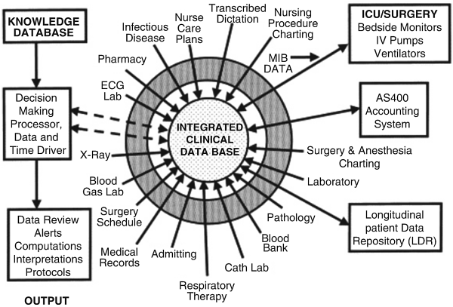
Fig. 8.11
The HELP system brought together data from virtually all areas of the hospital to create an integrated clinical database to drive its decision making processor. (Courtesy Springer)
Expert panels organized much of the clinical knowledge in an early example of knowledge engineering. In fact, in 1997, Dr. Warner published the book Knowledge Engineering in Health Informatics.⁵ Figure 8.12 is a diagram from that book. In it you see how clinical findings link to a diagnosis. Note the logical rule which states that if findings a or b and any two of the other four findings are present in the same patient, the diagnosis is confirmed.
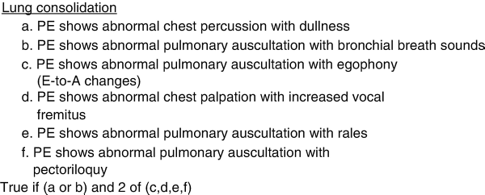
Fig. 8.12
A group of clinical findings on physical examination (PE) when combined with logic rules programs the decision making processor to recognize a specific problem, in this case lung consolidation. (Courtesy Springer)
In Fig. 8.13 you see that HELP used Bayesian statistics to relate findings to diagnoses. The first column in this Bayesian Frame is the True Positive (TP), the probability that the finding will be present if the patient has the condition. Thus, it is virtually certain that a patient with iron deficiency anemia will be both anemic and iron deficient. The second column is the False Positive (FP), the probability that a patient with that finding does not have the condition. Thus only 10% of anemic patients have a basis for that anemia other than iron deficiency. The Bayes equation is applied sequentially to these findings where their value is known to calculate the probability that the diagnosis is present in the patient.
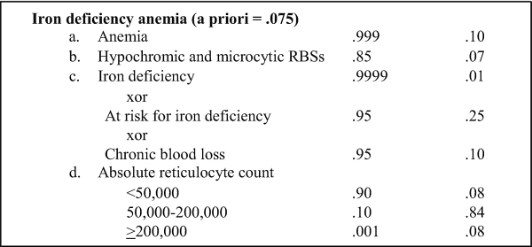
Fig. 8.13
This figure shows how HELP uses Bayesian statistics. The first column in this Bayesian Frame is the True Positive (TP), the probability that the finding will be present if the patient has the condition. The second column is the False Positive (FP), the probability that a patient with that finding does not have the condition. The Bayes equation is applied sequentially to these findings where their value is known to calculate the probability that the diagnosis is present in the patient. (Courtesy Springer)

8.10 MYCIN
MYCIN is another early example of the use of expert system and artificial intelligence techniques to provide clinical decision support. Specifically, it was an early backward chaining expert system. This technique starts with the goal (is there an antibiotic whose use is supported by the clinical evidence) and works back to the available data to see if it provides the necessary support for a clinical recommendation. MYCIN also provided dosage adjusted for patient’s body weight. The software was written in Lisp (one of the oldest programming languages dating back to the late 1950s, the name derives from “LISt Processor”) as the doctoral dissertation of a future health informatics pioneer, Edward “Ted” Shortliffe.⁶ The name derives from a commonly used family of antibiotic drugs. Interestingly, Shortliffe worked in the same lab that developed DENDRAL, an even earlier expert system to aid chemists in determining the structure of organic molecules.
According to Dr. B.J. Copeland, Director of the Turing Archive for the History of Computing, University of Canterbury, MYCIN worked well: “using about 500 production rules, MYCIN operated at roughly the same level of competence as human specialists in blood infections and rather better than general practitioners.”⁷
Despite this impressive performance, MYCIN was never used in routine clinical practice. Beyond concerns expressed about using an expert system in patient care, MYCIN, like virtually all clinical decision support systems, suffered from being stand-alone systems requiring the use of a unique user interface and re-entry of already recorded clinical data. As a result, according to Wikipedia, “a session with MYCIN could easily consume 30 minutes or more—an unrealistic time commitment for a busy clinician.”⁸
Figure 8.14 presents a high level view of MYCIN’s architectures. It is a simplified representation so while the patient data come from the clinician and the rules come from experts both the clinicians and the experts use the same system. The ‘start’ box applies to both of them. The rule acquisition system (subprogram 3) is available only to experts, but to identify necessary adjustments to the knowledge base, they use subprograms 1 and 2 to run cases. When they note problems, they then use subprogram 3 to “fix” existing rules or add new ones. The clinician uses only subprograms 1 and 2 in order to get advice. He or she enters patient data while using subprogram 1.
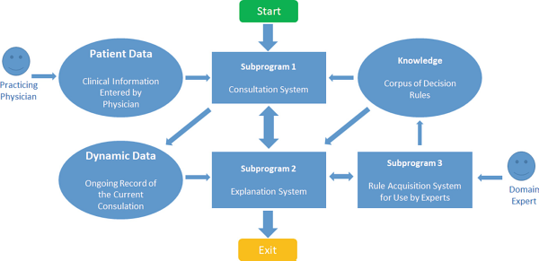
Fig. 8.14
The MYCIN architecture shows that, once again, clinical rules derived from experts inform the expert system. This tedious approach is now rapidly giving way to ‘deep learning’ which can derive the rules from vast quantities of digital medical record (and other) data. (Courtesy of Dr. Ted Shortliffe)
Like HELP, MYCIN depending on some 600 rules derived from expert clinicians. It is worth noting that today this step would likely be replaced with the deep learning tools increasingly able to figure out the rules based on the analysis of vast stores of digital data that are now available in an era of electronic health record systems. However, in a communication with the author, Dr. Shortliffe points out “that there is still a place for knowledge-based guidance of the ML methods. Blind pattern recognition, even with “deep” approaches, can go awry in ways that any expert would see reflect the lack of domain knowledge within the algorithms.”
In response to a physician query MYCIN provided a ranked list of possible bacteria, the probability of each diagnosis with its confidence in each diagnosis and the reasoning behind each diagnosis (list of questions and rules which led to its ranking). Finally, it recommended a drug treatment.
In 1988 Dr. Shortliffe recognized that the computers on which MYCIN was designed to run were rapidly disappearing so he recorded a set of three videos demonstrating the system.⁹ , ¹⁰ , ¹¹

8.11 INTERNIST
INTERNIST was an arguably even more ambitious early CDS. It was developed starting in 1974, at the University of Pittsburgh by Dr. Jack Myers, an internal medicine physician, and Dr. Harry E Pople, a computer scientist and pioneer in artificial intelligence. Health informatics is not often the first place a new computer science technique appears but, according to volume 64 of the Encyclopedia of Library and Information Science, “Applying Abduction to artificial intelligence problems began with Harry Pople and his system, INTERNIST.”¹²
The 1985 book Logic of Discovery and Diagnosis in Medicine describes the program as “an AI partial simulation of Dr. Myer’s clinical reasoning using his own internal knowledge base”.¹³ Once again clinical rules derived in this case from one practitioner were the basis for the expert system.
The goal of INTERNIST was to make the appropriate diagnosis in a given clinical situation. In the 1985 book Dr. Pople describes the methods used. They are summarized here.
He explains why either a Bayesian approach or a branching logic approach (essentially a network) that starts with a presenting complaint, as shown in Fig. 8.15, are inadequate to deal with the real world of clinical diagnosis where new or conflicting data may arrive too late to assist with an interim decision, and it may even arrive in random order.
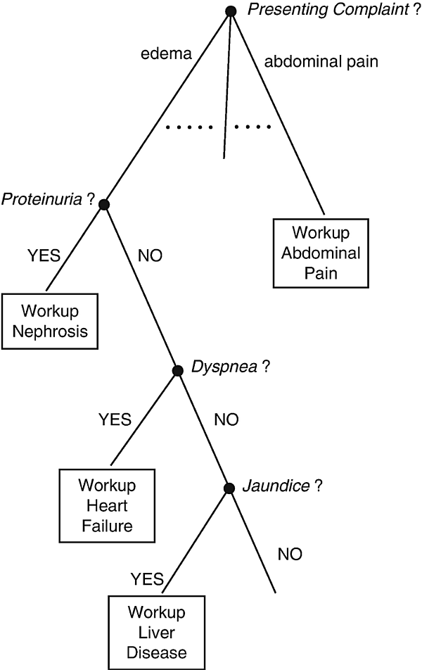
Fig. 8.15
A branching logic approach starting with the presenting complaint was determined to be inadequate for INTERNIST to deal with real world clinical diagnosis because the needed data might arrive too late or in random order. (Artificial Intelligence in Medicine, 1982)
INTERNIST contained a knowledge base consisting of some 500 disease entities, organized into categories by organ system, and their over 3,000 clinical manifestations. The diagram of liver diseases and their related conditions and manifestations in Fig. 8.16 illustrates these relationships and is from a chapter by Dr. Pople in the 1982 book Artificial Intelligence in Medicine.¹⁴ Each disease entity had a corresponding list of manifestations weighted on a scale of 1–5 (the weightings aren’t shown in the figure) based on the frequency of their occurrence in that disease. Conversely, a scale of 0–5 reflected the strength of the association of manifestations to diseases. Finally, there was representation of causal, temporal and other relationships among entities. This structure is in many ways suggestive of SNOMED-CT, whose predecessor, SNOP, was by then in operation at NIH but there is no way to know now if the INTERNIST team was aware of it.
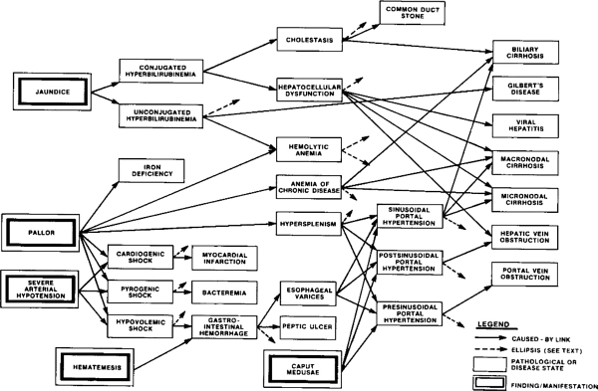
Fig. 8.16
A map of clinical relationships and from INTERNIST links various manifestations, their interrelationships and their association with a group of liver diseases shown on the right. (Artificial Intelligence in Medicine, 1982)
INTERNIST ranked disease entities that explain any or all of a patient’s findings reflecting their goodness of fit to the data. It then formulated questions for the physician, as shown in Fig. 8.17, to discriminate among the equally ranked entities. In this example, the computer is considering the diagnosis of Acute Disseminated Intravascular Coagulopathy (DIC) a dangerous, potentially life-threatening condition in which blood clots form in the small blood vessels. Much like an attending physician might do on rounds with physicians in training, it is asking for the results of the pertinent laboratory tests to confirm or rule out the diagnosis. Once a diagnosis was considered identified it was added to the patient’s problem list; its manifestations were considered accounted for; and the process repeated.
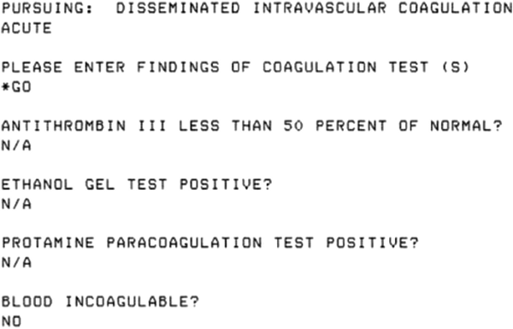
Fig. 8.17
Once it developed its list of possible diagnoses based on how well they were supported by the clinical findings INTERNIST asked the clinician user questions to further discriminate and attempt to reach a final diagnosis. (Artificial Intelligence in Medicine, 1982)
While INTERNIST worked, in complex cases it often considered inappropriate possibilities and wasted clinicians’ time answering questions with respect to them. To overcome this, INTERNIST-II used a heuristic that recognized that certain manifestations are distinctively characteristic of a disease or category of diseases. Jaundice, which is prominent in Fig. 8.16, is highly suggestive of liver disease so the initial focus in a patient with this symptom should be on this disease category, as it would be if a physician were making the diagnosis.
INTERNIST-II also introduced a multi-problem generator, essentially a search process beginning globally with ‘health problem’ as shown in Fig. 8.18. It terminated when at least one problem hypothesis accounted for all clinical findings. However, the hypotheses might or might not specify specific diseases. If there were sufficient cues in the data, further hypothesis reduction could reduce the possibilities to specific problems. Finally, it further reduced the problem list by exploiting its database of causal, temporal and other relationships, yet another process analogous to what actual human physicians do.
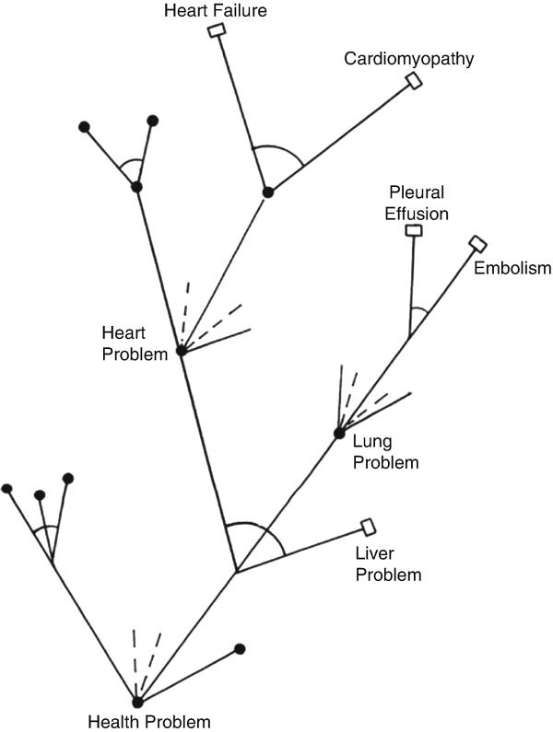
Fig. 8.18
INTERNIST-II introduced a multi-problem generator, essentially a search process beginning globally with ‘health problem’, as shown here. It terminated when at least one problem hypothesis accounted for all clinical findings. (Artificial Intelligence in Medicine, 1982)

8.12 Arden: A Standard for Medical Logic
Systems such as HELP and INTERNIST are impressive, but each employed their own approach to the representation of clinical knowledge and logic. Developing these systems was a substantial effort, far too formidable for most institutions that might lack either the clinical or computer science expertise to take on such a project. Clearly, it would be preferable to implement existing knowledge and clinical logic in institutions other than the one in which they were developed. Doing so inevitably means finding a way to connect their ‘clinical logic’ to other EHRs.
The HL7 Arden Syntax for Medical Logic Modules (MLMs) is an American National Standards Institute (ANSI) approved language for encoding medical knowledge and representing and sharing that knowledge. The primary goal is sharing of medical logic across EMRs for Clinical Decision Support (CDS).
A first draft of the standard was prepared in 1989 at a meeting at the Arden Homestead in Harriman, NY. The homestead is part of Columbia University and Dr. George Hripcsak , now chair of its Department of Biomedical Informatics, led the effort. The American Society for Testing and Materials (ASTM) adopted the Arden standard and published it in 1992. Later, the standard was integrated into Health Level Seven (HL7) which published Arden Syntax version 2.0 in 1999 and has been hosting its further development ever since. The latest version, 2.10, was published in November 2014.
Arden’s design borrowed from the HELP system that eventually converted to the syntax. Arden also borrowed from the Regenstrief Institute’s CARE language , a rule-based syntax that could generate reminders or retrieve patient records based on pre-specified criteria.¹⁵ CARE, and the Regenstrief Institute Record System (RMRS), are other early and important innovations in health informatics. RMRS development, begun in 1972 using data from 35 of Dr. Charles Clark’s diabetes patients, was headed by another health informatics pioneer, Dr. Clement J. McDonald , who we mentioned earlier as the organizer of the LOINC development effort. RMRS was one of the first EMR systems to offer rule-based CDS. Three hospitals on the Indiana University Medical Center campus and more than 30 Indianapolis clinics currently use RMRS.¹⁶

8.13 Arden Explained
The basic building blocks of Arden clinical decision support rules are Medical Logic Modules (MLM) each of which contains sufficient knowledge to make a single clinical decision. As illustrated in Fig. 8.19, MLMs use the Backus-Naur Form (BNF), a notation for context-free grammars, otherwise used to describe the syntax of computer programming languages, document formats, instruction sets and communication protocols.
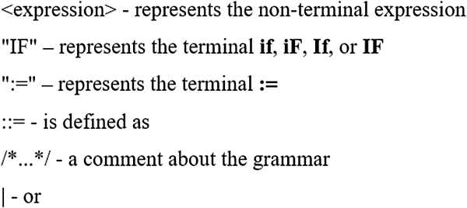
Fig. 8.19
Arden MLMs use the Backus-Naur Form (BNF), a notation for context-free grammars, otherwise used to describe the syntax of computer programming languages, document formats, instruction sets and communication protocols. (Courtesy Dr. George Hripcsak)
Each MLM can have four categories of information: maintenance, library, knowledge and resources. The examples in Figs. 8.20 and 8.21 are from Dr. Hripcsak. Figure 8.20 illustrates two categories. The category names and the key parts of the logic are highlighted. The purpose of the Library category of this MLM is to check each new penicillin prescription for a penicillin allergy. In the Knowledge category the triggering event is that the newly prescribed medication belongs to the penicillin class. Of course, the way to determine that might well be EHR specific. Later in this MLM you see the logic to evaluate the decision and the action to take if its value is ‘true’.
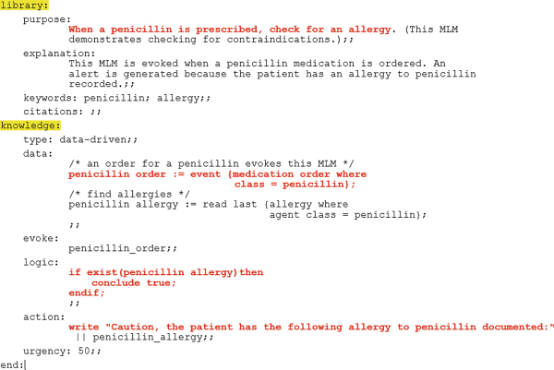
Fig. 8.20
The purpose of the Library category of this MLM is to check each new penicillin prescription for a penicillin allergy. In the Knowledge category the triggering event is that the newly prescribed medication belongs to the penicillin class. (Courtesy Dr. George Hripcsak)
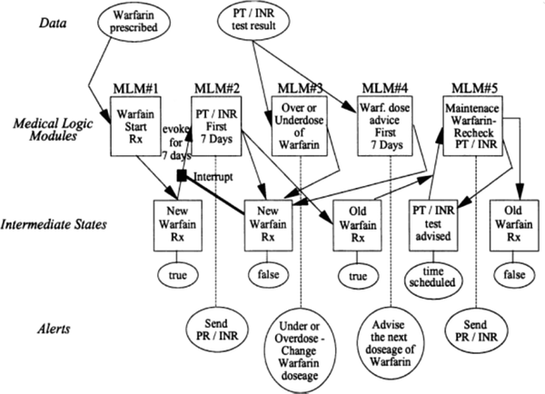
Fig. 8.21
An example of how a set of Arden MLMs can be combined to create a clinical decision support run. This example is for the appropriate prescribing of Warfarin, a notoriously difficult drug (for preventing blood clots) to manage. (Courtesy Dr. George Hripcsak)
Keep in mind that each MLM can drive one decision so, in practice, a group of MLMs may be required. In Fig. 8.21 five MLMs help provide CDS for the use of warfarin, a common but potentially dangerous, blood thinner often given to patients after thrombotic strokes caused by clots or to treat other potential blood clotting problems. Too little of the drug may mean another stroke. Too much can cause excessive, and even fatal, bleeding. Warfarin interacts with many other drugs, and even the patient’s diet, so it is a tricky drug to manage. Physicians use a test called PT/INR to assess the degree of blood thinning to manage the warfarin dose in each patient. The modules – using clinical data about the patient, including their PT/INR – can make warfarin dosage recommendations.
There is now an Arden XML schema (Fig. 8.22) that details all four categories. In addition to the two categories we saw earlier, each MLM also contains management information to help maintain a knowledge base of MLMs and links to other knowledge resources. Health personnel can create MLMs and implement them in any EHR or clinical information system that conforms to the Arden specification.
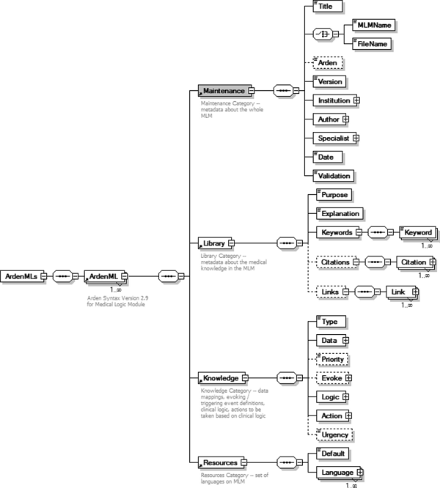
Fig. 8.22
A diagrammatic representation of the Arden XML schema detailing all four categories of Arden MLMs. (Courtesy Dr. George Hripcsak)
Figure 8.23 is the part of an MLM that helps with a radiologic study that involves injecting the patient with a contrast dye to highlight the functioning of parts of their internal organs. It specifically deals with a lab test – the creatinine level – that measures kidney function. It is important to know the patient’s kidney status before giving the dye, because the kidneys remove the dye and it can cause kidney damage so it shouldn’t be given to a patient with already compromised kidney function. As a result, Arden needs to know the creatinine level and, to get it, {‘dam’="PDQRES2"}, which is highlighted in Fig. 8.23, must be interpreted by the EHR in a particular hospital to fetch that value from its proprietary database.
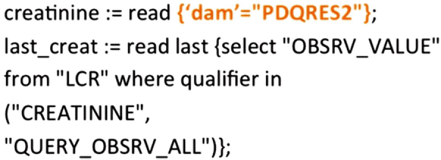
Fig. 8.23
The part of an MLM that reads the last creatinine level from an EHR. The part of this in ‘curly braces’ must be replaced with the specific query needed to access data in the EHR where the CDS is being used. This need for site specific customization impeded Arden adoption and, as a result, came to be called the ‘curly braces problem’. (Courtesy Dr. George Hripcsak)
The purpose of Arden is to share CDS logic but, because EHRs have not been readily interoperable, to implement Arden locally each instance where the Arden MLMs need to access data in the hospital’s EHR would have to be mapped to the data structure and representation of data items used by that EHR. Even the same EHR implemented in different hospitals may not do these things the same way due to decisions made when it was configured and installed. This understandably led to low Arden adoption. The impediment is so serious and widely known that it even has a name – the curly braces problem .
This leads us to one of the key advantages of FHIR and SMART on FHIR apps mentioned earlier as reasons for this discussion of CDS. FHIR-enabled EHRs would present creatinine in a reasonably consistent form in a FHIR Observation Resource. As a result, a hypothetical CDS SMART on FHIR app need have no knowledge of the EHR’s internal data structure or representation. It would not need to be adapted to each EHR, greatly reducing development cost and facilitating implementation and, hence, the likelihood of CDS adoption.
You may also recall that an impediment to MYCIN adoption, despite its superior performance to even infectious disease experts, was the time required to use an external tool that was not well integrated into the workflow and process of the busy physicians who could benefit from using it. FHIR and SMART on FHIR, if properly implemented, also resolve this long-standing impediment to CDS use. We will discuss this in the next chapter. First, we will look at some of the contemporary approaches to supporting CDS, including two that are employing FHIR.

8.14 Contemporary Tools for CDS Authoring and Dissemination

infobuttons
Earlier we discussed an IOM report that identified seven ‘information intensive’ aspects of its vision that current EHRs often fail to provide. In that discussion we introduced the notion that EHRs would ideally be ‘clinically adaptive’ which is to say they could provide information relevant to the particular clinical context and the specifics of that patient.
infobuttons are an interesting attempt to provide this missing EHR functionality through context-specific links that would provide specific information of interest given factors such as the provider specialty, the clinical context, or the patient’s characteristics. This was a decade after Arden began and was part of an effort to utilize the then new technologies of the Internet in clinical information systems.¹⁷ infobutton development was led by James Cimino , MD now Director, Informatics Institute, School of Medicine, University of Alabama and Guilherme Del Fiol now Assistant Professor in the University of Utah’s Department of Biomedical Informatics. It became an HL7 standard in 2010.¹⁸
The nuances of adding clinical context is explained in more detail in the following quotation from a 2012 article in the Journal of Biomedical Informatics that reported on a survey of 17 organizations that had attempted to implement the standard.
infobuttons use the context of the interaction between a user and a clinical information system to predict the information needs that are most likely to occur and to retrieve content from online knowledge resources that may address these needs. Context can be represented in terms of a set of attributes that describe (1) the patient (e.g., gender, age); (2) the clinical information system user (e.g., discipline, specialty, preferred language); (3) the task being carried out in the clinical information system (e.g., order entry, problem list review, laboratory test result review); (4) the care setting (e.g., outpatient, inpatient, intensive care); and (5) the clinical concept of interest (e.g., a medication order, a laboratory test result, a problem).¹⁹
A revised specification provided an implementation guide for representing the context parameters that clinical information systems could send to knowledge resources via a URL. Special software called an Infobutton Manager would use those parameters to lookup the relevant information in a knowledge base and return a list of topics likely to be of interest. Each topic is, in turn, a link to a web page containing the matching information. As explained on the apparently inactive original infobuttons site “if a user is reviewing a patient’s prothrombin time (a test of blood coagulation), an Infobutton Manager might provide links to various references about drugs that affect prothrombin time (such as warfarin sodium). If the patient is an adolescent or adult female, some of the links might be specifically related to pregnancy and breastfeeding recommendations. If the patient is a patient at New York Presbyterian Hospital, a link will be provided to the relevant age-specific hospital guidelines for the use of warfarin sodium.”²⁰
Curating content at this level of specificity is challenging so the National Library of Medicine and the University of Utah worked on a tool called Librarian Infobutton Tailoring Environment (LITE) aimed at supporting non-technical personnel (such as clinicians and librarians) to specify the resources that an Infobutton manager should provide, given a specific set of circumstances (for example, a nurse reviewing an adolescent female patient’s potassium test result).
Today the effort is housed in the OpenInfobutton project that provides a current HL7 compliant release 2.2 version of the Infobutton Manager and LITE.²¹

MAGICapp
MAGIC is a research driven initiative based in Denmark whose goal is to improve the creation, dissemination and maintenance of digital clinical practice guidelines, evidence summaries and decision support tools. It is led by Dr. Per Olav Vandvik a professor in the School of Medicine of the University of Oslo. It developed the MAGIC Authoring and Publication Platform (MAGICapp), a web-based platform for structured digital authoring, dissemination and dynamic updating of evidence summaries, recommendations and clinical decision support tools.
The MAGICapp authoring pipeline is shown in Fig. 8.24. It, in turn, rests on two separate concepts – PICO and GRADE. PICO is strategy for formulating clinical questions and search strategies. The acronym stands for its four elements which are:
- Patient, Population or Problem: The characteristics of the patient or population (demographics, risk factors, pre-existing conditions, etc.) or what is the condition or disease of interest?
- Intervention: What is the intervention under consideration?
- Comparison: What is the alternative to the intervention?
- Outcome: What are the relevant outcomes?²²
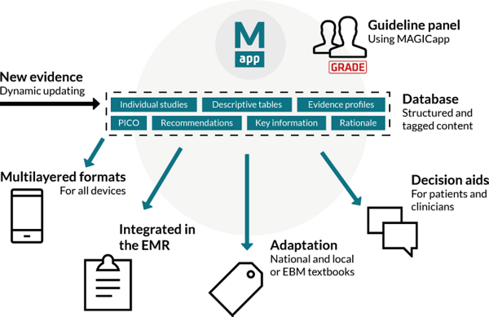
Fig. 8.24
The MAGICapp pipeline begins with new medical evidence which is put into a structured and tagged format suitable for the various purposes shown. (Courtesy Dr. Per Olav Vandvik)
GRADE is a widely used methodology for grading the quality (or certainty) of medical evidence and the strength of recommendations derived from it.²³
MAGICapp is well described by this paragraph from the MAGIC Project site:
The PICO linked data model applied in MAGICapp breaks down the concept of a guideline document into discrete elements of content. This way of digitally structuring data allows content to be published in multilayered and flexible formats, usable on all devices and facilitates adaptation and dynamic updating of individual recommendations in a living guideline model. The linked data structure – combined with a coding module for annotating PICO questions and recommendations with terms from various structured terminologies and making the data available through an API – allows for connections (EHR, other platforms), re-use and sharing of data across the Ecosystem.²⁴
Several interesting examples of MAGICapp are posted on the MAGIC Project site. You should try one or more since it is far easier to understand the tool by seeing it than it is to adequately explain it in text. One robust example compares two surgical treatments for severe aortic stenosis in low-intermediate risk patients.²⁵
We will now look at two examples of contemporary clinical decision support using FHIR. These could have been placed later on but the seemed to fit topically here. They do refer, albeit lightly, to some concepts we haven’t formally discussed yet so you may wish to read or re-read them after the two chapters on FHIR and SMART on FHIR that follow.

Case Study : Zynx Health
The company was founded in 1996 by a group of clinicians at Cedars-Sinai Medical Center in Los Angeles as a wholly owned subsidiary of the hospital. It was acquired by Hearst in 2005. An earlier pilot project had demonstrated the value of evidence-based guidelines in hospitals, suggesting to the founders that there was an opportunity to improve patient care.
The company’s clinical experts accumulate and appraise peer-reviewed research, national guidelines, and performance measures. The evidence sources are classified and summarized with the goal of providing its clients with unbiased coverage of the most trustworthy research and quality measures. The evidence is offered as user-customizable products that are typically delivered through software as a service and include:
- A system used by hospitals and outpatient physicians for developing and maintaining order sets based on clinical evidence, making use of rules, reminders and other tools to assist with physician decision making.
- A care plan development system designed for hospital nursing staff and interdisciplinary teams, helping clinicians customize evidence-based plans of care.
- A reference resource online database of clinical evidence drawn from medical and interdisciplinary literature, peer-reviewed research, and national guidelines and performance measures that is the content foundation on which other Zynx Health products are based.
- A knowledge management solution that maximizes the value of your computerized provider order entry (CPOE) system and aligns your organization across desired clinical and financial goals.
As illustrated in Fig. 8.25, the Zynx Health Developer Program offers a FHIR API that makes over 800 PlanDefinition resources available containing evidence-based care guidance. Third-party solution developers can utilize these resources to assist providers in their delivery of patient care through adherence to these evidence-based standards.
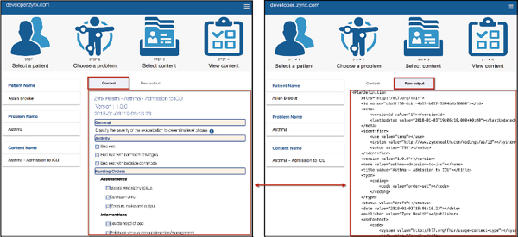
Fig. 8.25
On the right is an example of a Zynx Health care guideline is delivered as an XML formatted FHIR PlanDefinition resource. On the left is an illustration of how that resource might be used in a provider-facing app to help determine the appropriate level of care for a newly admitted asthma patient
Interested potential developers can sign up at the developer site and receive an API key that will make two complete PlanDefinition resources available for demonstration purposes.²⁶ Additionally, a demonstration application for using the API key can be downloaded from the Zynx Health API demonstration GitHub repository.²⁷
The company has plans to make its evidence-based content available through a Zynx FHIR API into SMART on FHIR applications and CDS Hooks.

Apervita
Earlier we discussed an article in the Harvard Business Review that discussed the transformative impact that APIs have had in other industries and said that it “health care industry followed suit, the impact on the quality and cost of care, the patient’s experience, and innovation could be enormous”.²⁸
A great deal of the discussion around APIs in this book will center on apps that use the FHIR standard to access data in EHRs. However, a second transformative factor in healthcare and industry in general is the increasing use of analytics and the various forms of machine learning to derive knowledge from large datasets. Many clinical decision support tools would benefit greatly from or would depend entirely on their ability to access the most up-to-date analytic algorithms to inform and personalize the advice they give to providers or patients. Those analytic algorithms in turn could continuously learn and improve based on the information they glean from interacting with the widest possible user group. Rather than baking these analytic algorithms into software it would therefore be advantageous to make analytics a web service accessible by APIs.
That is the mission of Apervita. The company provides what it describes as a secure, self-service platform for the development and delivery of analytic tools which it says can scale to the extent that its users require. The company says it can integrates with many EMR systems to ingest data in real time or batch, or through the Apervita web service APIs. It can return the results of essentially any arbitrary clinical calculation such as an alert, score, text, quality report, chart, or dashboard within a browser window, iFrame , the recipient EMR’s native alerting framework, or other capabilities supported by the EMR including SMART on FHIR.
Similar to the smartphone app marketplaces you are familiar with and the similar FHIR app galleries you will read about later, Apervita offers its clients a Marketplace to share or even market their analytic tools to others in the Apervita user community.

8.15 Recap
Standards provide more structured ways of exchanging, interpreting and ultimately using information. Since the early days of HL7 and the other standards development organizations we have discussed, healthcare standards have evolved and typically grown more complex over time. An important consideration in any standards development effort is not just how well the standard represents the nuances in the information being represented but the success of the standard in increasing the use of the information to help solve practical real world challenges. The discussions in this chapter provide the reader with important background and context from which the FHIR standard was born.
Footnotes
1
http://​www.​vico.​org/​HL7_​V3_​CD1_​2012/​Edition2012/​infrastructure/​vocabulary/​ProcessingMode.​html

2
https://​www.​hl7.​org/​fhir/​v3/​ProcessingMode/​vs.​html

3
http://​www.​healthintersecti​ons.​com.​au/​?​p=​1924

4
http://​ccda.​art-decor.​org/​ccda-html-20150727T182455/​index.​html

5
http://​www.​springer.​com/​us/​book/​9780387949017

6
http://​www.​shortliffe.​net/​

7
https://​www.​britannica.​com/​technology/​MYCIN

8
https://​en.​wikipedia.​org/​wiki/​Mycin

9
https://​www.​youtube.​com/​watch?​v=​a65uwr_​O7mM&​t=​5s

10
https://​www.​youtube.​com/​watch?​v=​ppkg4mQIgXw&​t=​6s

11
https://​www.​youtube.​com/​watch?​v=​bro6fkDxCUE

12
https://​tinyurl.​com/​y88anayb

13
https://​tinyurl.​com/​yb4hcr5r

14
https://​tinyurl.​com/​yasrmqe8

15
McDonald, CJ et al. Implementing Healthcare Information Systems, Orthner, Helmuth F., Blum, Bruce (Eds), Springer, 1989, p 82.

16
http://​www.​sciencedirect.​com/​science/​article/​pii/​S138650569900009​X#BIB25

17
https://​www.​ncbi.​nlm.​nih.​gov/​pubmed/​10175348

18
http://​www.​hl7.​org/​implement/​standards/​product_​brief.​cfm?​product_​id=​208

19
https://​www.​sciencedirect.​com/​science/​article/​pii/​S153204641100220​6

20
http://​www.​infobuttons.​org/​

21
https://​github.​com/​VHAINNOVATIONS/​InfoButtons

22
http://​linkeddata.​cochrane.​org/​pico-ontology

23
http://​www.​gradeworkinggrou​p.​org/​

24
http://​magicproject.​org/​research-and-tools/​living-guidelines/​

25
https://​www.​magicapp.​org/​app#/​guideline/​1308

26
http://​developer.​zynx.​com

27
https://​github.​com/​zynxhealth/​api-demo

28
https://​hbr.​org/​2015/​12/​the-untapped-potential-of-health-care-apis

