© Springer International Publishing AG, part of Springer Nature 2018
Mark L. BraunsteinHealth Informatics on FHIR: How HL7's New API is Transforming Healthcare https://doi.org/10.1007/978-3-319-93414-3_10

10. SMART on FHIR
Mark L. Braunstein¹
(1)
School of Interactive Computing, Georgia Institute of Technology, Atlanta, GA, USA

10.1 A Grand Challenge
A universal health app platform to support informatics-based innovations in care delivery, no matter what the underlying EMR, was a long-held dream of the academic health informatics community. In 2010, the ONC awarded $15 million to the Boston Children’s Hospital Computational Health Informatics Program and the Harvard Medical School Department of Biomedical Informatics to create and initially develop just such an app platform.
The result was SMART, an acronym for “Substitutable Medical Apps, Reusable Technology ” that was intended to be an open, standards-based technology with a robust community of app developers. The SMART effort developed an API that leveraged web standards such as HTML, JavaScript, OAuth, Resource Description Framework (RDF) and widely adopted data standards such as RxNorm, LOINC and SNOMED-CT in order to present ‘predictable data payloads’ thus obviating the need for apps to deal with the details of the underlying health information system’s data structures and representations. Systems that implemented all or part of the SMART API were called ‘containers’.
This approach placed a burden on that underlying system. “To enable such substitutability, the SMART architecture imposes a substantial burden of normalization on any container, allowing apps to know upfront what data to expect and what each data element means. An important implication is that some containers may need to reshape underlying data to support the SMART API.” To avoid adding to this burden the SMART API was read only.¹
Despite this, according to an article by the SMART team “through mid-2013, EHR vendors were not receptive. At the time, third-party medical apps were not yet an important near-term business driver. In addition, vendors raised objections to the SMART data model and API because they had not been developed in conjunction with the health IT standards community. Vendors also identified specific technical obstacles to adoption, such as our focus on clinical data to the practical exclusion of other types, e.g., administrative data; no perceived advantage to RDF over “plain” extensible markup language (XML) or JavaScript Object Notation (JSON); concerns about our solution to a write API; and the lack of population-level API.”²

10.2 The Evolution to SMART on FHIR
As the preceding section documents, SMART development preceded FHIR but the approach had difficulty gaining traction with the major EHR vendors in part because it had not been developed within a standard setting body. As HL7’s FHIR effort became more significant, the SMART project shifted its strategy to the development of a technology layer that builds on the FHIR API and resource definitions. Today it is known as SMART on FHIR but the project team often uses SMART to refer to it. SMART on FHIR is now widely adopted by the same major EHR vendors that objected to the original SMART technology.

10.3 SMART on FHIR Technology Stack
As we explained earlier, FHIR provides a set of “core” data models (resources) but many FHIR fields and value sets may not be constrained to support specific requirements across varied regions and use cases. To enable substitutable health apps as well as third-party application services, SMART on FHIR applies a set of “profiles” that provide developers with expectations about the vocabularies they should use to represent medications, problems, labs, and other clinical data.
In the United States SMART on FHIR has adopted the profiles outlined in the Argonaut Implementation Guide we discussed in the previous chapter.³ This takes advantage of the broad adoption of Argonaut by the EHR vendor community. Also as part of the Argonaut Project, the five largest EHR vendors either have or will build SMART on FHIR into current or future releases of their products. The vendors, the SMART on FHIR team and HL7 are working together to standardize the SMART on FHIR API in HL7 specifications.
Clearly, third party apps must not access protected health information without establishing trust in who is using those apps and respecting patient privacy choices. To facilitate this, SMART on FHIR provides login and data access authorization models based on the OpenID Connect ⁴ and OAuth2 ⁵ standards that are already widely used on the Internet and elsewhere. In what follows we will look at how SMART on FHIR uses these technologies.
Through the SMART on FHIR Genomics and SMART CDS Hooks efforts, the SMART on FHIR project is helping define the next generation of FHIR based standards for the clinical use of genomic data and the integration of clinical decision support into provider workflows. We will also discuss these efforts later.

10.4 Developer Support
To support running apps within the EHR’s user interface, SMART on FHIR allows web apps to run inside browser widgets or inline frames. It also supports native and mobile apps.
To make it easier for developers to get started building apps the SMART on FHIR project offers a set of open source libraries for HTML5/JavaScript,⁶ Apple’s iOS⁷ and Python.⁸
SMART on FHIR also offers a free, web-based API “sandbox” that developers can use to test their apps as well as a locally installable version that developers can download and run on their own system. Figure 10.1 shows the public sandbox that supports installing an app and testing it using sample patients, practitioners and data. For example, there is an extensive set of vital signs data that is available for testing. Developers can also create patient and practitioner ‘personas’ and use them in “Launch Scenarios” to test their app.⁹
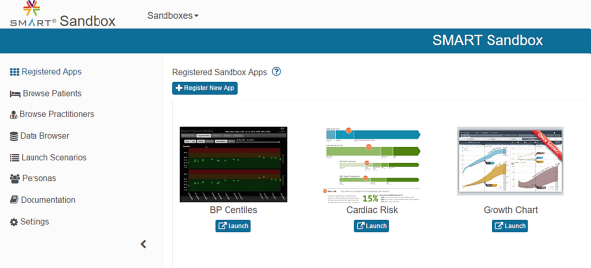
Fig. 10.1
The SMART on FHIR public sandbox supports installing an app and testing it against sample patients, practitioners and data. (Courtesy SMART)
Projects often have specific data requirements so SMART offers FRED, an open web-based, interactive FHIR resource editor to help developers create sample data for their apps.¹⁰ You may wish to try using FRED to build a FHIR Resource of your choice. As shown in Fig. 10.2, you can input some elements of the data elements contained in a FHIR patient resource and export it in FHIR JSON Patient resource format. FRED code and more information about the tool is available on GitHub.¹¹
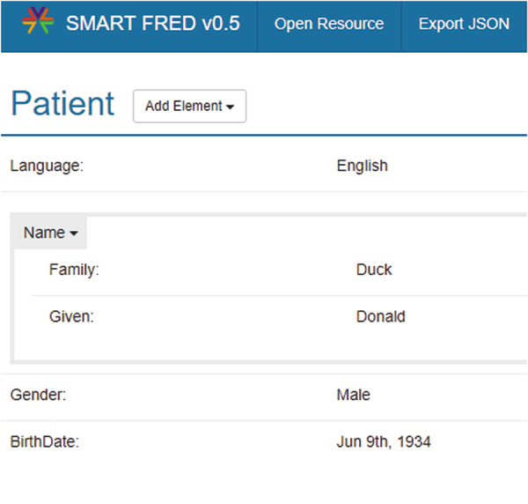
Fig. 10.2
SMART on FHIR’s FRED tool makes it easy to use user entered data to create a wide variety of FHIR resources. (Courtesy SMART)
SMART’s C3-PRO is a software library that integrates the SMART on FHIR platform with ResearchKit , Apple’s open source framework to enable iOS apps to become tools for medical research.¹² We will discuss ResearchKit in more detail in the final chapter of this book.
Finally, the SMART on FHIR site offers extensive documentation.

10.5 OAuth2
OAuth2 is a widely used authorization framework that enables web and desktop applications, as well as mobile devices, to obtain specified, constrained access to user accounts on an HTTP web service.
OAuth2 defines four roles:
- Resource owner
- Resource server
- Authorization server (can be the same server as the Resource server)
- Client (in the case of SMART this would be a FHIR app)
The resource server hosts the protected information. The authorization server verifies the identity of the prospective user of that information and then issues access tokens to the client application. You might recall that in the discussion of Apple Health’s support of FHIR for patients to access their records it was Geisinger’s OAuth2 authorization server that managed access to that data.
An OAuth2 scope specifies the level of access (such as ‘read’ or ‘write’) that the application is requesting. In the case of SMART on FHIR the scope might specify what FHIR Resources can be accessed for a specified patient and how much of CRUD the app can perform on those resources.
In SMART on FHIR when an EHR user launches an app, it gets a “launch request” notification. The app asks for the permissions it needs using OAuth scopes such as “patient/*.read”.
In the case of a launch within an EHR charting session, the scope “Patient/*.read” refers to the patient whose chart is in use at the time of the launch. The term for this is “in-context” and this request only makes sense within a charting session. The app does not yet know who that patient is when it requests the scope. It learns that from the access token response, where the “patient” property will provide the FHIR Patient Resource ID.
To review, in response to its scope request, the app receives an access token with the permissions it needs – including access to clinical data and context like:
- which patient is in-context in the EHR
- which encounter is in-context in the EHR
- the physical location of the EHR user
These so called ‘launch parameters’ are an extremely important capability of SMART on FHIR. As we discussed earlier, tools such as clinical decision support have existed for decades but have not found wide use. To coin a small pun, providing this context literally allows the app to be ‘smarter’ avoiding work for its clinical user and thereby increasing the attractiveness of using the app.

10.6 Scopes and Permissions
In the example we just discussed our hypothetical scope request contained a wildcard (*). Through it, the client app is seeking permission to obtain all available and future FHIR resources stored on the server for the current patient. This raises the issue of patient privacy. The authorization server asking a patient to authorize a SMART app requesting patient/*.read should inform the patient that they are being asked to allow the app access to all currently available and future FHIR resources that might contain potentially more sensitive data such as their genomic variations. Of course, as we discussed when we looked at HealthVault, giving the patient usable tools to make an informed decision about what they are willing to share remains a challenge.
However, the granular nature of FHIR Resources could certainly facilitate the development of such a tool. This would be particularly true if, as illustrated in Fig. 10.3, which is a MedicationRequest example from the FHIR site, the FHIR resources contained the reason (e.g. condition) for which orders and procedures were ordered. If they did, then a patient might specify that they wish to share only information related to a particular clinical problem and the app could figure out what that information is.
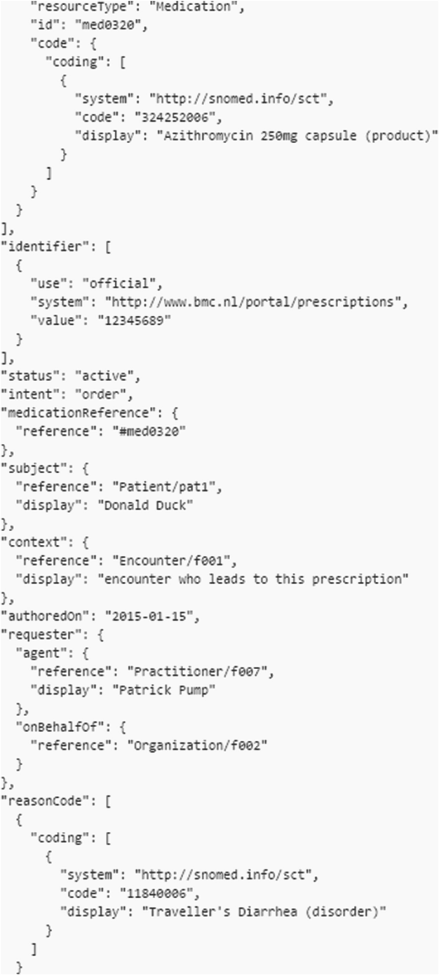
Fig. 10.3
This MedicationRequest resource documents that the drug (Azithromycin) is being given for a specific reason (traveler’s diarrhea) facilitating patient permissions for sharing data about a specific condition while not sharing other data the patient might feel is sensitive. (Courtesy HL7)
At present, these ‘cause and effect’ relationships are not specified in all the potentially applicable resources. Even if they were, this is not just an issue for the standard. A solution would require vendor support of the idea in their EMR and provider willingness to take the time to indicate these relationships. Alternately, this may well be another opportunity for machine learning to infer relationships from the data recorded over many patient encounters. To give a simple example, if virtually all patients with diabetes have had a hemoglobin A1c test and almost no other patients have had the test done then it would be possible to infer that this test is ordered for diabetes and hemoglobin A1c results could be automatically released to an app to which the patient has given permission to obtain all information about their diabetes.
The authorization server may not grant the level of access requested by the app. For example, an app with the goal of obtaining read and write access to our old friend, the patient’s AllergyIntolerance resources, requests the clinical scope of patient/AllergyIntolerance.*. The authorization server may respond in a variety of ways as shown in Fig. 10.4. For example, the authorization server might grant only read access as illustrated in the third granted scope in the figure. App designers should anticipate this and their apps should consider the permissions granted to them and they may need to change their behavior accordingly.
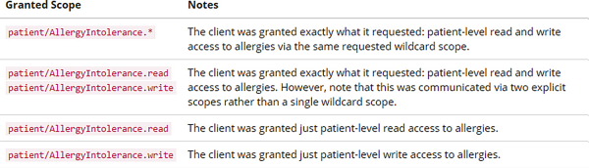
Fig. 10.4
The authorization server may respond in a number of ways to the scope request of “patient/AllergyIntolerance.*” asking for access to read and write AllergyIntolerance resources. (Courtesy SMART)

10.7 OpenID Connect
As we just discussed, in many cases SMART apps launch within the context of an existing EHR charting session where the provider, patient and encounter are clear. In other contexts, SMART may need to use OpenID Connect, a simple identity layer on top of the OAuth 2.0 protocol. It enables apps to verify the identity of the end user based on the authentication performed by the authorization server and obtain basic profile information about the end user.
To use OpenID Connect the app asks for the OpenID scope when it requests authorization and it will have access to a UserInfo endpoint that exposes user information referred to in OpenID as “claims”. In SMART these include the end user’s name and their unique National Provider Identifier (NPI), a 10-digit number assigned by CMS to providers that uniquely identifies them across healthcare organizations.

10.8 SMART App User and Access Authorization
A SMART app must be registered with an EHR’s authorization service before it can be run within that EHR and access data from it. The registration technology is up to the EHR vendor although SMART recommends the OAuth 2.0 Dynamic Client Registration Protocol. No matter how an app registers, at registration time it must register one or more fixed, fully specified URLs and redirect URLs so the EHR knows how to launch it.
EHRs can offer SMART apps to the provider in ways that greatly increase their likelihood of use. Figure 10.5 is an example of a SMART on FHIR app launching within Cerner’s PowerChart® EHR. Note along the bottom left of the screen that the SMART on FHIR apps are in the same main menu that the physician uses for other charting activities. This greatly facilitates access to the apps and saves time by eliminating extra clicks. In this case, the widely used Meducation app has received the necessary scopes and permissions to obtain the patient’s medications so no further input from the physician is required. Also, note that the display of the app’s patient education information conveniently appears in the usual clinical data entry/presentation area of the EHR screen so, for all practical purposes, although its user interface is different, it appears to be functionally a part of the EHR.
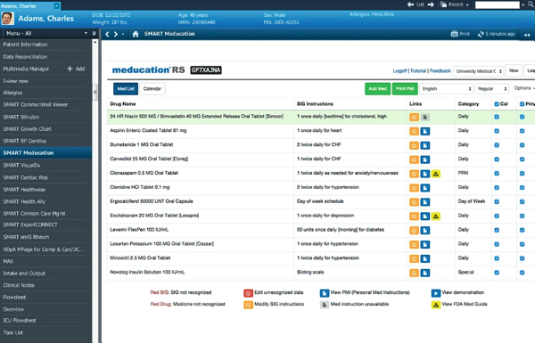
Fig. 10.5
The Meducation app is launched from the main menu of the Cerner PowerChart EHR (note the highlighted menu choice) and its information is displayed in the same area where physicians normally do charting. The app has received the necessary scopes and permissions to obtain the patient’s medications so no data input by the physician is required. (Courtesy Meducation)
Alternatively, as shown in Fig. 10.6, an app can launch as a standalone iOS or Android app. This is a design prototype done by a group of Georgia Tech students for an app that supports epilepsy patients via their smartphones. This kind of standalone patient facing app and apps for providers launching within an EHR session are probably the most common use cases for SMART on FHIR.
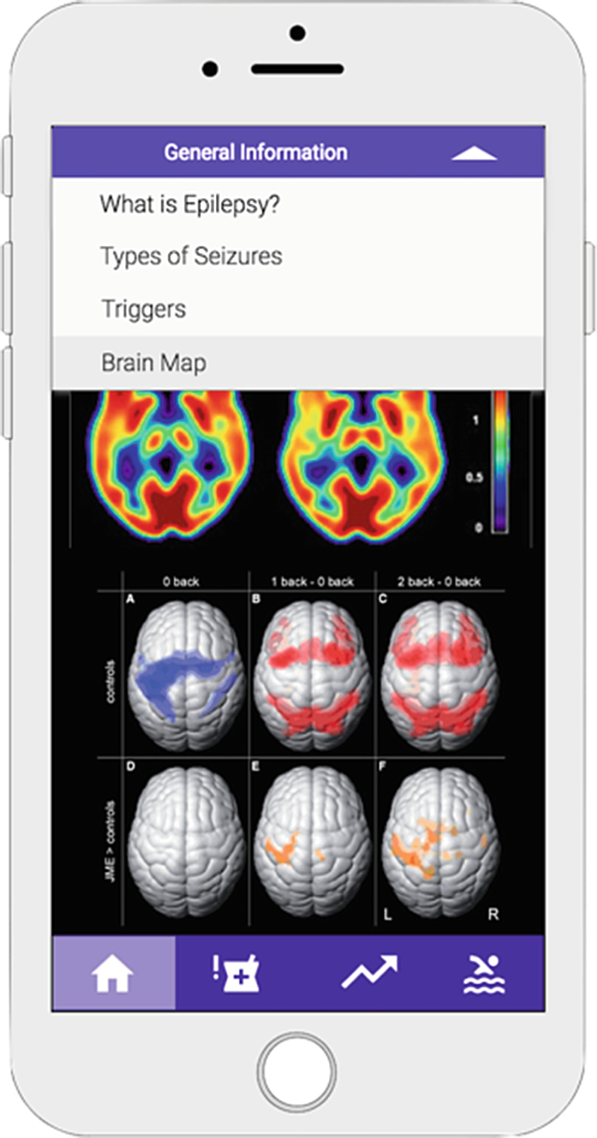
Fig. 10.6
A stand-alone smartphone app developed by a team of Georgia Tech students supports patients in managing their epilepsy
In an EHR launch , SMART passes an opaque¹³ handle or pointer to the EHR context to the app as part of the launch URL. The app later will include this context handle as an OAuth authorization request parameter when it asks for authorization to access resources. Note again that the complete URLs of all apps approved for use by users of this EHR must be registered with the EHR’s authorization server. When an app is launched standalone from outside an EHR context, it requests authorization to access a FHIR resource by redirecting its authorization request to the EHR’s authorization server. Based on pre-defined rules and possibly end user authorization, the EHR authorization server either grants the request by returning an authorization code to the app’s redirect URL, or denies the request. The app then exchanges the authorization code for an access token, which the app presents to the EHR’s resource server to obtain the FHIR resource(s). If a refresh token comes along with the access token, the app may use this to request a new access token, with the same scope, once the original access token expires.
This has been just a basic discussion of SMART App Authorization. The important details are readily available on the excellent SMART on FHIR site.¹⁴ There are also numerous web tutorials about OAuth2 and OpenID Connect. Google provides an interactive OAuth2 “playground”.¹⁵

10.9 SMART Backend Services
A new arm of SMART supports developers of back-end services to use SMART to access FHIR resources by requesting access tokens from OAuth 2.0 compliant authorization servers. As with apps, the backend service must be authorized in advance and must:
- Run automatically, without user interaction
- Be able to protect a private key
- Require access to a population of patients rather than a single patient
Such a service might, for example, review incoming laboratory results, and generate clinical alerts when specific trigger conditions exist or it might maintain an external database of patient data for research purposes.

10.10 CDS Hooks
If you think back to our discussion of FHIR apps integrated into EHRs, it should be clear that the decision to initiate the apps rests with the EHR user. This, in turn, rests on the user recognizing that an app exists that might be of benefit in a particular patient care scenario. Clinicians are busy so it is easy to imagine that this might not happen. Very much along the lines first explored by Arden, the CDS Hooks initiative within SMART provides a means of embedding clinical logic within the EHR to invoke decision support, which might or might not be a full FHIR app. Unlike with Arden this occurs within a clinician’s EHR workflow and, because of FHIR, there is no ‘curly braces problem’ since clinical data will be provided in a predictable, standard format.
A “hook” is functionality provided by software for users of that software to have their own code called under certain circumstances. Clinical examples of such circumstances might include:
- opening a new patient record
- authoring a new prescription
- viewing pending orders for approval
Under such circumstances CDS Hooks can display ‘cards’ to provide useful information or offer apps to help make optimal clinical decisions.
There are three kinds of CDS Hooks cards. Information cards convey text. Alternative suggestion cards provide an action different from the one contemplated. App link cards suggest the use of an app or reference materials.
Figure 10.7 is a screen shot from the interactive CDS Hooks demonstration tool to show how a hook inserted into the code for recording new prescriptions causes the display of a Suggestion Card. This example explains the potential savings if a generic equivalent replaces the brand name drug the provider input.¹⁶
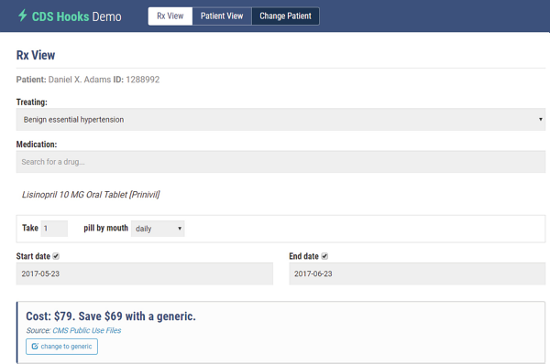
Fig. 10.7
Using FHIR, a CDS Hooks card realizes that the physician is prescribing a brand name drug for a patient’s hypertension and displays this information in an attempt to suggest that the prescription might be for a lower cost generic medication saving $69. (Courtesy SMART)
This example raises an issue that may only slowly be addressed by EHR vendors. In this prescribing example it would obviously contribute to the acceptance of the advice if the physician could simply click on the ‘change to generic’ button at the lower left of the card. In practice this means that the EHR must allow ‘write’ access to its medication records. At present virtually all EHR vendor support of FHIR is read only. This is, of course, a regulatory requirement but writing to the EHR isn’t. This will likely change over time but it may not occur as rapidly as many would like.

10.11 Specifying Quality Measures and Clinical Logic for Decision Support
The specification of clinical quality measures and clinical logic for decision support are somewhat related challenges. Quality measures must specify the population that is subject to the measure and the computations needed to evaluate the measure. Similarly, decision support artifacts must provide criteria describing which patients should be the recipient of a particular intervention.
For example, if the quality measure is the percentage of patients with diabetes who have had a hemoglobin A1C test (as specified by a list of LOINC codes) within the prior year (the numerator in the calculation), the applicable group of patients (the denominator in the calculation) would be those with diabetes (as specified by a list of condition codes in SNOMED-CT and/or ICD). Additional criteria such as age or gender might further stratify the population into subgroups. A decision support artifact might provide the criteria (again using the same list of condition codes in SNOMED-CT or ICD) to identify those patients who have diabetes but have not had the A1C test (using the same list of LOINC codes) done in the prior 12 months so that the clinician can be reminded to order the test.
Although standards exist for these purposes, the domains of quality measurement and clinical decision support have used different standards. Harmonization of these different approaches would enable broader sharing of computable clinical knowledge, as well as reduce the burden on authors and implementers responsible for producing and consuming that knowledge.
Earlier we discussed FHIRPath as a means or extracting specific data from one or more FHIR resources. Clinical Quality Language (CQL) is an HL7 standard used to describe the logic used by knowledge artifacts such as clinical decision support rules, quality measure logic, and conditions and actions under which specific sets of orders or care protocols would be administered to a patient. CQL expressions generally provide a means of computing new information from existing data. CQL is being extended to use FHIRPath as its core path language to represent paths within queries.¹⁷
For example, given a patient with multiple names, each of which has multiple givens, the following CQL query will return a single list containing all the given names:
expand (Patient.name X where X.given is not null return (X.given Y where Y is not null))
The following FHIRPath expression will do the same thing:
{"resourceType": "Patient", "name": [{"given": ["John"]}]}
You can see an online demonstration of this FHIRPath expression.¹⁸ CDS Hooks does not specify how the clinical logic to be embedded in the EHR will be specified but CQL with FHIRPath is at present the likely candidate for this role.

10.12 FHIR Genomics
Personalized or precision medicine are synonymous terms for the concept of using rich and potentially broad datasets about an individual patient to guide optimal diagnosis and treatment decisions that are as specific to that patient as possible. These datasets might supplement the traditional clinical record with behavioral, environmental, socioeconomic and genomic information. Behavioral data is largely the domain of mHealth, a later topic.
Genomic datasets are very large. Current estimates of a single patient’s genome are around 3,200 MB or 3.2 × 10⁹ base pairs. As a result, genomic data is unwieldy for direct use in patient care. The goal of the FHIR Genomics effort is to make genomic data usable and useful for patient care. Among other things, it is defining a new FHIR sequence resource, shown in part in Fig. 10.8, which contains the most clinically relevant data.¹⁹ SMART on FHIR apps that can present that data to clinicians in useful ways.
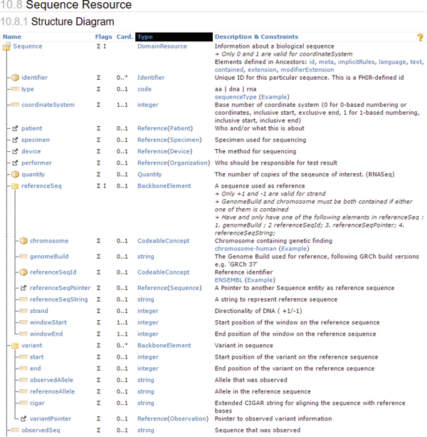
Fig. 10.8
Unsurprisingly given the complexity of the genome, the Genome Sequence FHIR resource , is itself very complex and this is only a part of it. (http://​wiki.​hl7.​org/​index.​php?​title=​FHIR_​Genomics). (Courtesy HL7)
Given the complexity of genomic data, it should not be surprising that this is perhaps the most complex FHIR resource yet specified. The specification includes instructions, as shown in Fig. 10.9, that explain how to document single nucleotide polymorphisms (SNPs), the most common type of genetic variation among people. SNPs occur approximately once in every 300 nucleotides, which means there are roughly 10 million SNPs in your genome. Their significance with respect to health and disease can vary greatly.
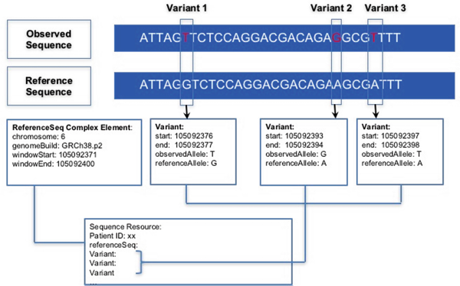
Fig. 10.9
The Sequence Resource specification includes instructions that explain how to document single nucleotide polymorphisms (SNPs), the most common type of genetic variation among people. Here the nucleotide thymine (T) in the observed sequence replaces the nucleotide guanine (G) in the reference sequence. (Courtesy HL7)
Each SNP represents a difference in a single DNA building block, called a nucleotide. In this example the nucleotide thymine (T) in the observed sequence replaces the nucleotide guanine (G) in the reference sequence. This substitution is documented in the FHIR Sequence resource.
Apps could access FHIR genomic resources from EHRs, genomic data repositories or specialized sequencing systems. The key effort for a data provider is implementation of a SMART on FHIR Genomics data adaptor, which creates a binding to convert between the standard SMART on FHIR Genomics format and the provider’s native format.
KRAS is an oncogene that, when mutated, has the potential to cause normal cells to become cancerous. Figure 10.10 is an early example of Vanderbilt School of Medicine’s prototype SMART Precision Cancer Medicine app usefully presenting genomic information in real-time by comparing a cancer patient’s diagnosis-specific detected gene mutations to a comparable population of cancer patients. It should be clear to you how the Sequence Resource we just discussed would support an app such as this one.²⁰
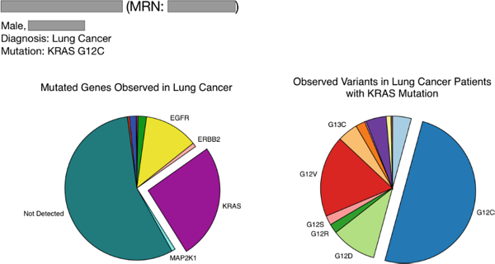
Fig. 10.10
Vanderbilt’s prototype SMART Precision Cancer Medicine app usefully presents genomic information in real-time by comparing a cancer patient’s diagnosis-specific detected gene mutations to a comparable population of cancer patients. (Courtesy SMART)

Demonstration FHIR App : Timely Display of Renal Function in the ICU
Earlier in our discussion of the Arden Syntax we reviewed an example of a set of Medical Logic Modules (MLMs) that deal with the use of the creatinine level as a measure of kidney function in preparation for a patient having a dye study that could be dangerous if that function is compromised.
Kidney status is a clinical factor in many situations and can be particularly important for the very sick patients in an intensive care unit (ICU). What we didn’t discuss earlier is that the creatinine level is a trailing indicator of kidney function. Creatinine is a byproduct of muscle metabolism that is removed from the blood by the kidneys. Blood circulates throughout the entire body so that process isn’t instantaneous. There is an inevitable delay between a change in kidney function and the resulting change in creatinine level. In normal medical practice this isn’t of any real significance because the delays are measured in hours. However, in a critical care situation it is important to know when kidney function changes including when it starts to improve so that treatment can be adjusted accordingly in a timely manner.
When kidney function first begins to improve, creatinine levels can continue to increase, but at a slower rate. As is illustrated on the left of Fig. 10.11, the traditional plot of creatinine levels versus time does not clearly convey the early improvements in kidney function (at point 4) that can signal the need to change treatment strategy.
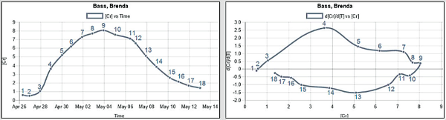
Fig. 10.11
The FHIR app discussed in this demonstration app created this pair of plots. The numbers along the plots correspond in time. In both plots, creatinine increases over time through point 9 and then begins to decrease. A traditional plot of creatinine versus time is on the left. On the right is a novel phase plot of creatinine level (X-axis) versus the first derivative of creatinine level divided by the first derivative of time (Y-axis). The phase plot makes it far more obvious that the rate of creatinine increase is decreasing after point 4. This signals the onset of renal function improvement much more clearly than can be appreciated in the traditional plot. (Courtesy Dr. Tim Buchman)
This change for the better becomes clear by displaying the data not as a time series, but rather as a representation of the trajectory of creatinine levels versus time – a phase plot (Δ[Creatinine]/Δt versus [Creatinine]) as shown on the right of Fig. 10.11. Here it is quite clear that improvement begins at point 4. Most clinicians using the traditional plot would recognize improvement of function at point 9 thereby delaying the needed adjustments in the patient’s treatment and possibly doing harm.²¹
Early in this book we discussed the clinical oversight provided to ICUs by an eICU at Emory. These graphs were produced by a FHIR app developed by a team of Georgia Tech students as a class project working under the direction of Cheryl Hiddleson RN, Director, Emory eICU Center and Timothy G. Buchman, Ph.D., M.D., Director, Emory Critical Care Center and Professor of Surgery and Anesthesiology, Emory University School of Medicine.
Understanding how this was done provides a simple illustration of what it means to transform clinical data in a traditional database into FHIR resources. In this case the data was stored in a Philips eICU system²² used by highly trained nurses and physicians to monitor care in the ICU and provide important oversight to make sure nothing gets overlooked. An example might be during a period of time when the ICU staff is focused on the care of a particularly critical patient.
As shown in Fig. 10.12, the student’s FHIR adapter software did scheduled queries of the SQL database in the eICU system looking for new creatinine entries.
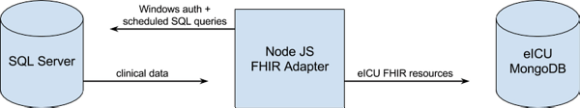
Fig. 10.12
The eICU FHIR adapter architecture. Clinical data (on the left) is pulled at regular intervals, formatted into FHIR resources, and placed into an eICU specific data mart (MongoDB on the right). (Courtesy Dr. Tim Buchman)
A FHIR REST API queries the data mart and responds with the JSON FHIR resources that the FHIR app expects. This project also illustrates that the clinical systems that can utilize FHIR apps may not be EHRs but could be virtually any system that stores a repository of clinical data.

Demonstration FHIR App : Sepsis Prediction in the ICU
The practice of medicine is largely about recognizing and appropriately responding to changes in patient status. We just saw an example of how a FHIR app could help physicians recognize a change in kidney function sooner than might otherwise be possible. However, no matter how timely that recognition is, it is still a response to something that has already happened. Might it be possible to predict the future with respect to changes in a patient’s status?
Earlier we discussed sepsis as a severe, life threatening and common condition particularly among patients in intensive care units (ICUs). The recognition and treatment of sepsis sooner has been shown to reduce mortality. A 2006 study of over 2,700 patients with septic shock (the most severe form) in 14 intensive care units in a mix of academic and community hospitals in Canada and the United States concluded that “Each hour of delay in antimicrobial administration over the ensuing 6 hours was associated with an average decrease in survival of 7.6%.”²³ However, the clinical recognition of sepsis is difficult because the symptoms “may range from non-specific or non-localised symptoms (e.g., feeling unwell with a normal temperature), to severe signs with evidence of multi-organ dysfunction and septic shock.”²⁴
Predictive analytics uses a variety of statistical techniques from predictive modelling, machine learning, and data mining to analyze known data to make predictions about future or otherwise unknown events. Given the value of earlier recognition of sepsis a great deal of attention is being given to using predictive analytics to help make the diagnosis earlier. Since the analytics depends on current and past clinical data on the patient, an EHR integrated FHIR app would be a very attractive platform for a predictive sepsis tool.
Previously, we briefly discussed Sepsis Watch, a FHIR app that predicts changes in six lab values that can be indicators of the onset of sepsis and alerts physicians to determine the current values. The Sepsis Monitor app was developed by a group of Georgia Tech students mentored by Dr. Shamim Nemati, Assistant Professor in the Department of Biomedical Informatics at Emory School of Medicine. The goal was a cross-platform sepsis prediction and alert application that would work with any FHIR enabled EHR. Given the critical importance of timeliness the FHIR app would interface with the EHR in real-time to monitor multiple patients, calculate a sepsis score based using a machine learning algorithm and alert the care team when the scores suggest that sepsis is developing using a visual interactive interface. The app would also record data for analysis to improve the algorithm over time.
As shown in Fig. 10.13, inputs into the algorithm include heart rate, body temperature, blood oxygen saturation and blood pressure and over 30 other variables but not all of these inputs are required for the tool to function. Missing data is estimated using population means from ICU patients in MIMIC III. MIMIC III is an openly available dataset developed by the MIT Lab for Computational Physiology, comprising de-identified health data associated with ~40,000 critical care patients. It includes demographics, vital signs, laboratory tests, medications, and more.²⁵
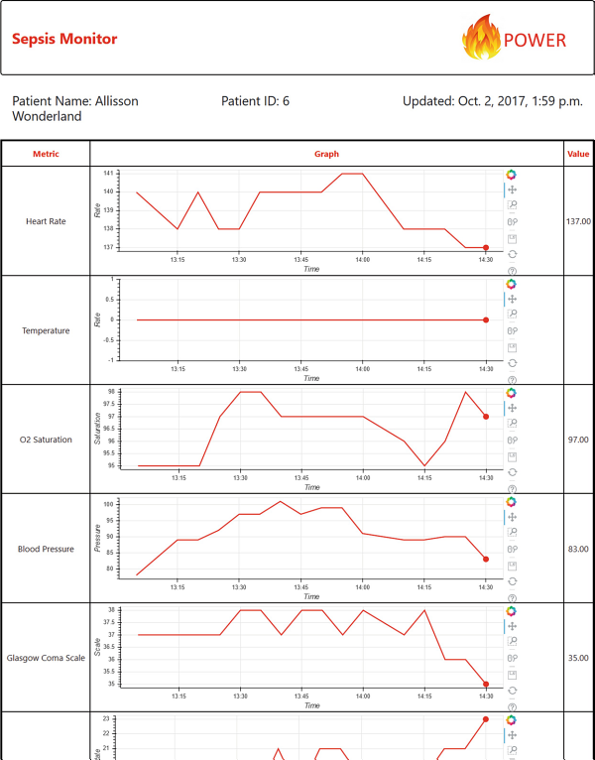
Fig. 10.13
The Sepsis Monitor FHIR app retrieves around 35 clinical variables from the simulated EHR. This is done using the MIT MIMIC ICU dataset that was mapped to OMOP and is therefore accessible as FHIR resources on the Georgia Tech HDAP server. Each variable is graphed and the most recent value is presented in the right most column. As shown in Fig. 10.14, Allisson Wonderland is at greatest risk of sepsis of the patients being monitored. (Courtesy Dr. Shamim Nemati)
As we discussed in the previous demonstration app, an ICU can be a busy place particularly if one of its patients is in distress. There is always the risk that something will be overlooked so a dashboard that clearly flags any patients who are at high risk for sepsis would be of potential value. The app provides just this, as shown in Fig. 10.14, and each patient is given a sepsis score of between 0 (low risk) and 1 (high risk of sepsis). Patients are listed in descending order of sepsis risk further minimizing the likelihood of anything being overlooked. Allisson Wonderland, the patient whose physiologic variables are shown in Fig. 10.13, had the highest risk score at the time this display was captured but that can change over time so continuous monitoring is critical in these patients.
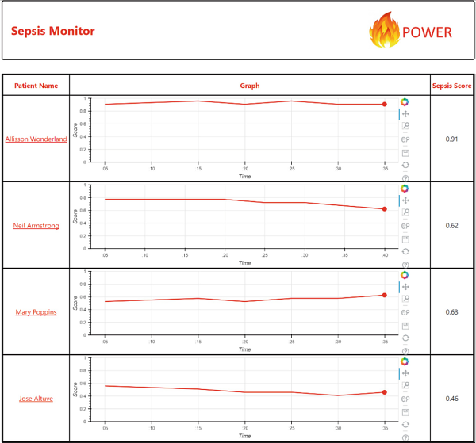
Fig. 10.14
Using the clinical variables shown in Fig. 10.13, the Sepsis Monitor FHIR app calculates a Sepsis Risk Score on a scale of between 0 (low risk) and 1 (high risk of sepsis). Allisson Wonderland is at greatest risk of sepsis of the patients being monitored at the time this display was captured but these are very sick patients who can be very unstable so this can change rapidly illustrating the value of a continuously updated dashboard. (Courtesy Dr. Shamim Nemati)
The details of the calculation of the Sepsis Risk Score are very technical. In this case it is done using a modified Weibull-Cox proportional hazards model that is one of the most popular forms of parametric regression models because it provides estimates of the hazard function, as well as coefficients for the variables that are possibly predictive of the outcome under study. A hazard function can be thought of as a measure of risk: the greater the hazard over some specified period of time, the greater the risk of an event in this time. In this case the time period is 4 h and the hazard function represents the risk of sepsis. The model has a prediction accuracy of over 80% which is felt to be sufficient for practical use in actual ICU patient care.²⁶

10.13 Recap
This chapter concludes Part III of the book. In the final part we will conclude by discussing some important and more dynamic and rapidly changing applications of health informatics.
Earlier in the book we discussed the need to enhance and extend functionality of existing health IT systems. SMART on FHIR provides a scalable, open framework that uses widely adopted solutions for identity authentication and authorization to access specific data. It accesses that data using the FHIR standard that is becoming a ubiquitous feature of the major electronic health record systems. This has led to the long sought goal of app stores for healthcare that support apps that can be relatively easily tuned to work with those EHRs. This facilitates innovation both because it substantially reduces the development effort to create cross platform tools and because it provides even startup companies with more efficient access to the potential end users.
We have seen a number of examples of the collaborations between end users and app developers that are becoming far more common as a result of this new ecosystem. We have also seen examples of the kind of innovative work that new entrants into the commercial FHIR app ecosystem are creating. Of course, innovations no matter how clever they may be, must be accepted by end users. The tight integration that SMART on FHIR facilitates between apps and the underlying EHR goes a long way toward solving the workflow and process issues that have long retarded provider acceptance of innovative solutions such as the early clinical decision support tools we have discussed.
It is probably too early to say that FHIR and SMART on FHIR have succeeded in transforming informatics into a practical everyday tool for providers and their patients but there is now ample reason to be optimistic that this may well be the case.
Footnotes
1
https://​dash.​harvard.​edu/​bitstream/​handle/​1/​10436330/​3384120.​pdf?​sequence=​1

2
https://​academic.​oup.​com/​jamia/​article/​23/​5/​899/​2379865?​rss=​1

3
http://​www.​fhir.​org/​guides/​argonaut/​r2/​

4
http://​openid.​net/​connect/​

5
https://​oauth.​net/​2/​

6
http://​docs.​smarthealthit.​org/​clients/​javascript/​

7
http://​docs.​smarthealthit.​org/​Swift-SMART/​

8
http://​docs.​smarthealthit.​org/​clients/​python/​

9
http://​docs.​smarthealthit.​org/​sandbox/​

10
http://​docs.​smarthealthit.​org/​fred/​

11
https://​github.​com/​smart-on-fhir/​fred

12
https://​github.​com/​C3-PRO/​c3-pro-ios-framework/​blob/​master/​C3PRO.​podspec

13
One that does not directly expose any data.

14
http://​docs.​smarthealthit.​org/​authorization/​

15
https://​developers.​google.​com/​oauthplayground/​

16
http://​cds-hooks.​org

17
https://​github.​com/​cqframework/​clinical_​quality_​language/​wiki/​FHIRPath:​CQL:​:​XPath:​XQuery

18
http://​niquola.​github.​io/​fhirpath-demo/​#/​

19
https://​www.​hl7.​org/​fhir/​sequence.​html

20
https://​apps.​smarthealthit.​org/​app/​smart-precision-cancer-medicine

21
https://​www.​ncbi.​nlm.​nih.​gov/​pubmed/​17622898

22
https://​www.​usa.​philips.​com/​healthcare/​product/​HCNOCTN503/​eicu-program-telehealth-for-the-intensive-care-unit

23
https://​www.​ncbi.​nlm.​nih.​gov/​pubmed/​16625125

24
http://​bestpractice.​bmj.​com/​topics/​en-gb/​245/​diagnosis-approach

25
https://​mimic.​physionet.​org/​

26
Joel R. Henry, Dennis Lynch, Jeff Mals, Supreeth P. Shashikumar, Ashish Sharma, and Shamim Nemati, A FHIR-Enabled Streaming Sepsis Prediction System for ICUs, 2018 40th Annual International Conference of the IEEE Engineering in Medicine and Biology Society (EMBC), Honolulu, Hawaii, July 17–21, 2018. – under review.

